4.3 Informational Text: Ionization Energy
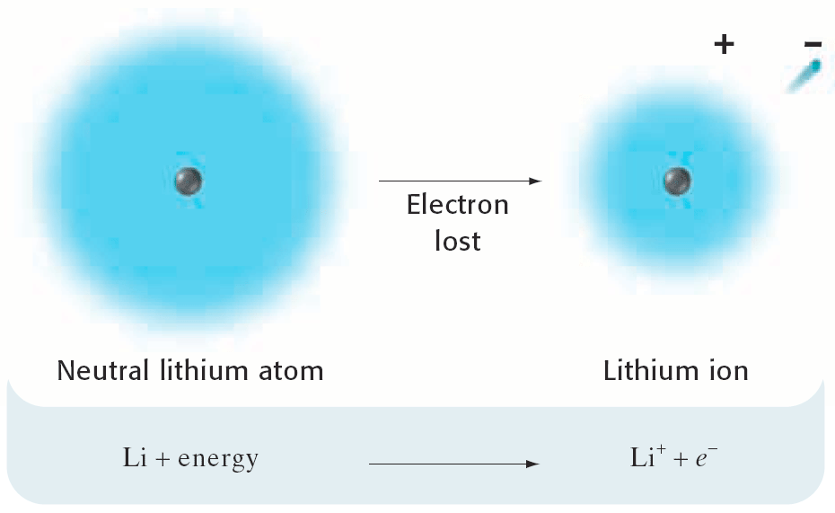
The ionization energy , or ionization potential, is the energy required to completely remove an electron from a gaseous atom or ion. The closer and more tightly bound an electron is to the nucleus, the more difficult it will be to remove, and the higher its ionization energy will be.

Units for Ionization Energy
Ionization energy is measured in electronvolts (eV) or kJ/mol.

First vs Subsequent Ionization Energies
The first ionization energy is the energy required to remove one electron from the parent atom. The second ionization energy is the energy required to remove a second valence electron from the univalent ion to form the divalent ion, and so on. Successive ionization energies increase. The second ionization energy is always greater than the first ionization energy.

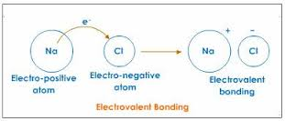
4.4 Informational Text: Electronegativity
Definition: A property of an atom which increases with its tendency to attract the electrons of a bond .

Electronegativity is a measure of an atom's ability to attract electrons to form a chemical bond. High electronegativity reflects a high capacity to bond electrons, while low electronegativity indicates low ability to attract electrons. Electronegativity increases moving from the bottom lefthand corner of the periodic table toward the upper righthand corner.

The Pauling scale is the most commonly used. Fluorine (the most electronegative element) is assigned a value of 4.0, and values range down to cesium and francium, which are the least electronegative at 0.7.

Examples:

The chlorine atom has a higher electronegativity than the hydrogen atom , so the bonding electrons will be closer to the Cl than to the H in the HCl molecule .

