4.5: Physical vs. Chemical Properties Informational Text

All substances have properties that we can use to identify them. Properties are descriptions of an object’s characteristics and behavior. For example we can identify a person by their face, their voice, height, finger prints, DNA etc.. The more of these properties that we can identify, the better we know the person. In a similar way matter has properties - and there are many of them. There are two basic types of properties that we can associate with matter. These properties are called Physical properties and Chemical properties:

Physical properties: | Properties that can be observed or measured without changing it
Chemical properties: | Properties that can only be observed by changing the chemical identity of a substance

Examples of physical properties are: color, smell, freezing point, boiling point, melting point and density. There are many more examples. Note that measuring each of these properties will not alter the basic nature of the substance.

Intensive Physical Properties - Properties that do not depend on the amount of the matter present.
    - Luster - How shiny a substance is.

    - Malleability - The ability of a substance to be beaten into thin sheets.
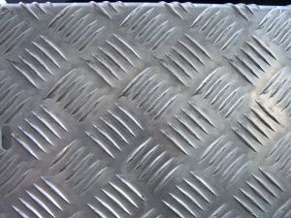
    - Ductility - The ability of a substance to be drawn into thin wires.
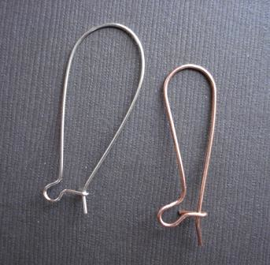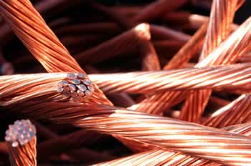
    - Conductivity - The ability of a substance to allow the flow of energy or electricity.
    - Hardness - How easily a substance can be scratched.
    - Melting/Freezing Point - The temperature at which the solid and liquid phases of a substance are in equilibrium at atmospheric pressure.
    - Boiling Point - The temperature at which the vapor pressure of a liquid is equal to the pressure on the liquid (generally atmospheric pressure).
    - Density - The mass of a substance divided by its volume

Extensive - Properties that do depend on the amount of matter present.
    - Mass - A measurement of the amount of matter in a object (grams).
    - Weight - A measurement of the gravitational force of attraction of the earth acting on an object.
    - Volume - A measurement of the amount of space a substance occupies.
    - Length

Examples of chemical properties are: heat of combustion, reactivity with water, PH, and flammability (ability to catch on fire).
    - Rust- formed by reaction of iron and oxygen in presence of water or air moisture
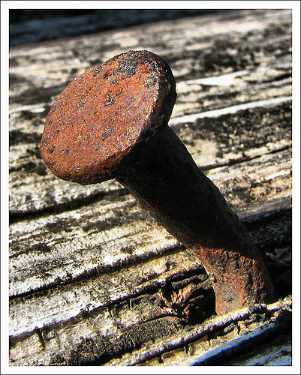
    - Tarnish- to lose luster/color as a result of corrosion because presence of water or air moisture
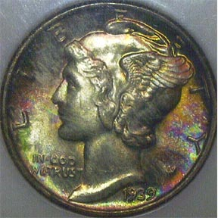

The more properties we can identify for a substance, the better we know the nature of that substance. These properties can then help us model the substance and thus understand how this substance will behave under various conditions.

4.5 Metals, Nonmetals, Metalloids Informational Text

On the Periodic Table, there are three major types of elements known as Metals, Non-Metals, and Metalloids, which exhibit different chemical and physical properties Here are a few properties of metals, non-metals, and metalloids:

Metals
75% of the periodic table is metals. In the periodic table, you can see a stair-stepped line starting at Boron (B), atomic number 5, and going all the way down to Polonium (Po), atomic number 84. Except for Germanium (Ge) and Antimony (Sb), all the elements to the left of that line can be classified as metals. The exception is hydrogen (H), the first element on the periodic table. At ordinary temperatures and pressures, hydrogen behaves as a nonmetal.
These metals have properties that you normally associate with the metals you encounter in everyday life:
- They are solid (with the exception of mercury, Hg, a liquid).
- They are shiny, good conductors of electricity and heat.
- They are ductile (they can be drawn into thin wires).
- They are malleable (they can be easily hammered into very thin sheets).
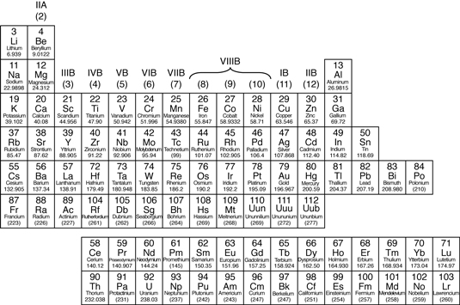

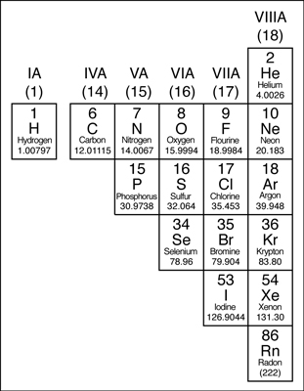
Nonmetals
Except for the elements that border the stair-stepped line, the elements to the right of the line are classified as nonmetals (along with hydrogen). Nonmetals have properties opposite those of the metals.
The nonmetals are brittle, not malleable or ductile, poor conductors of both heat and electricity, and tend to gain electrons in chemical reactions. Some nonmetals are liquids. These elements are shown in the following figure.

Metalloids
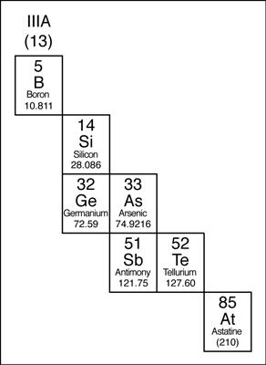
The elements that border the stair-stepped line are classified as metalloids. The metalloids, or semimetals, have properties that are somewhat of a cross between metals and nonmetals.
Metalloids tend to be economically important because of their unique conductivity properties (they only partially conduct electricity), which make them valuable in the semiconductor and computer chip industry. The metalloids are shown in the following illustration.

