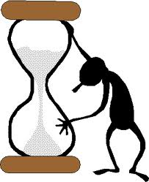
Date: | MAD MINUTE: Dimensional Analysis (Conversion)
Directions: Solve the following problems as quickly and accurately as possible Use conversion factor method.

Question  1000mg = ___g | Answer | Question  14km = ______m | Answer
109g = _____kg |  | 250mm = ______m
160 cm = _____m |  | 56 cL = _____L
1L = ____mL |  | 19.8g = _____dg
Question  5.6s = _____cs | Answer | Question  54.6s = ______ms | Answer
53.6dL = _____L |  | 2500m = ____km
536 mg = _____g |  | 630mm = _____m
3,600s = _____ ms |  | 100 cm = ____m
0.9325kL = _____L |  | 79cL = ____L

