Packet #1
UNIT 1:
Chemathematics

/ | Completed Class Notes
/ | Completed Classwork
/ | Completed Homework
/20 | Handed Packet in on Time
/ | Expectations Tracker
/ | Total Points
Comments:

Due Date: ____________________

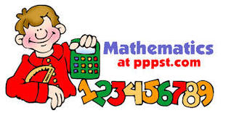

DAILY EXPECTATIONS TRACKER

To ensure EVERY student is doing what he/she needs to do,
I am holding you accountable to follow daily class expectations.

Following each expectation = 5 points
MAX # of points = 100 points

It is YOUR RESPONSIBILITY that Ms. Francois stamps/checks this by the end of the period.
You CANNOT get it any other time!!!!!

You will NOT receive a check if you did not follow all classroom policies or actively work on the practice problems during the allotted class time. Ms. Francois is the final judge about you following daily expectations.

 | Arrive on Time | Participation  in Class | Behavior | Classwork effort | Homework completion
Monday
Tuesday
Wednesday
Thursday
Friday

Table of contents

1.1 | SI Units
1.2 | Unit Prefixes
1.3 | Unit Conversions
1.4 | Significant Figures

Contact information

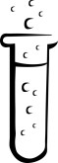
Email: pfrancois@hs-gc.org

Website: msfrancoischem.weebly.com

1.1
Aim:

Objective:

Real world connection:

Vocabulary: *SI Unit * Unit * Meter * Gram * Second * Kelvin * Celsius * * Liter *

CLASS NOTES

SI System
In England, people measure human weights in stones. A person can say, “I weight six stones.” As Americans, we wonder what that means. Just like when you go to a different country and say it’s 80ºF, others have no ideas what we are talking about. UNITS ARE IMPORTANT!!!

New Terms:

TERM | DEFINITION
The SI System

Unit

CLASS NOTES
1.1

The Fundamental Units

To find the Selected Units used in chemistry,
we can look at _______________ in the reference table.
To Measure | Unit | Abbreviated Unit (Symbol) | Instrument
Length/Distance
Time
Mass
Temperature
Volume

The WUS System:

Example: Ms. Francois wishes she had walked 10 kilometers the other day.

Example
What is being measured? (in words)
Unit
Symbol

1.1
CLASS NOTES

Directions: Pick out the W, U, and S in each of the following word problems:

- Johanna has a mass of 60 kilograms.
W: U: S:
- Christina took a shower for 15 minutes.
W: U: S:
- Daniel walked for a really long time. He walked for 6.8 kilometers.
W: U: S:

Summary: Why is it important to use the proper units of measurement?

CLASS WORK
1.1

Odd One Out: Circle which one is the one out. Then explain why that term is the odd one out AND how are the other terms related to each other.

Which is the Odd One? | Why is it the odd one out? How are the other terms related?
Celsius degree
Kelvin
Mass
Fahrenheit

Which is the Odd One? | Why is it the odd one out? How are the other terms related?
Grams
Balance
Second
Mass

Which is the Odd One? | Why is it the odd one out? How are the other terms related?
Kilogram
Liter
Cubic Centimeter
Volume

Which is the Odd One? | Why is it the odd one out? How are the other terms related?
Time
Second
Distance
Clock

Which is the Odd One? | Why is it the odd one out? How are the other terms related?
Decimeter
Kilometer
Ruler
Thermometer

CLASS WORK
1.1

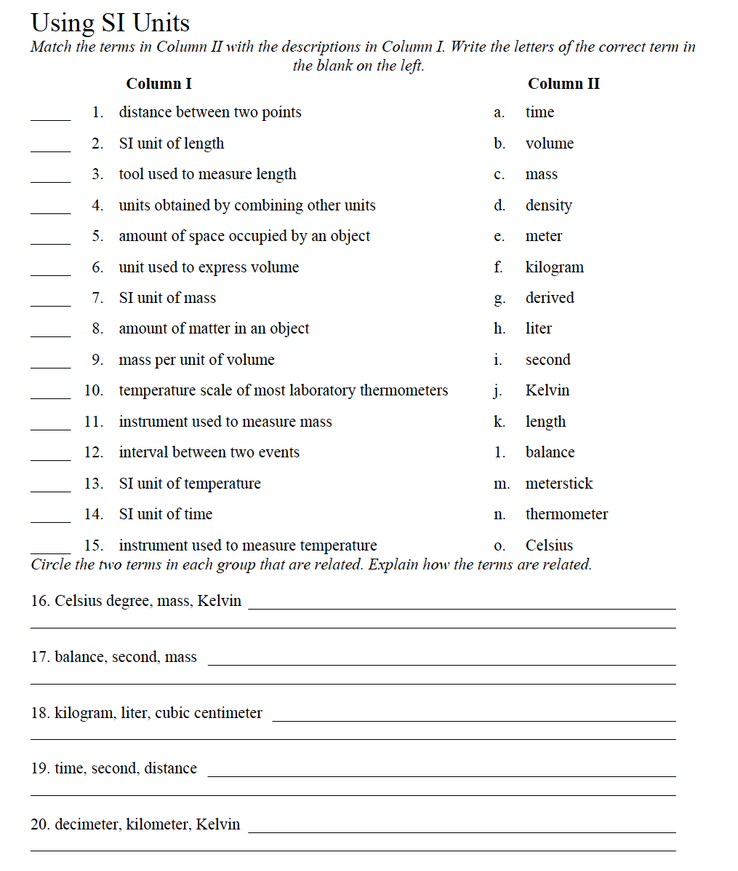

1.2
Aim:

Objective:

Real world connection:

Vocabulary: * Prefix * kilo- * deci- * centi- * milli- * nano- * pico- *

CLASS NOTES

SI Prefixes
To find the Selected Prefixes used in chemistry,
we can look at _______________ in the reference table.
Prefixes for Powers of 10
Prefix | Symbol | Factor (Notation) | What it really means
 |  |  | Long # form | Words
Kilo- |  | 10³
Deci- |  | 10⁻¹
Centi- |  | 10⁻²
Milli- |  | 10⁻³
Micro- |  | 10⁻⁶
Nano- |  | 10⁻⁹
Pico- |  | 10⁻¹²

CLASS NOTES
1.2

Sample Questions: Multiple choice questions: Circle the key words.

- Which of these units for mass is the largest?
- microgram
- gram
- milligram
- kilogram

- Which of these units for length is the smallest?
- $μm$
- $mm$
- $nm$
- $pm$

Writing Units with Prefixes

IN WORDS:

- When writing units of numbers with prefixes in WORDS, you must have:
- __________________
- __________________

- These parts are written as one word.

- Example: ( ) Kilogram ( )

IN SYMBOLS:

- When writing units of numbers with prefixes in symbols, you must have:
- _________________
- _________________

- These parts are written as one word.

- Example: ( ) kg ( )

CLASS NOTES
1.2

Write the correct form of the unit with prefixes.

What is being measured? (Circle it) | Unit | Symbol
Bridgette missed the train by 45.2 nanoseconds

T-Andra drank 20 milliliters of juice today.

Summary: What do the prefixes indicate about the value of a measurement?

CLASSWORK
1.2

Circle the more reasonable measure:
a) length of an ant: 5mm or 5cm
b) length of an automobile: 5 m or 50 m
c) distance from NY to LA: 450 km or 4,500 km
d) height of a dining table: 75 mm or 75 cm

Circle the larger unit in each pair of units.
1. millimeter, kilometer 2. centimeter, millimeter 3. centrigram, decigram

4. decimeter, meter 5. milligram, kilogram

In SI, the base unit of length is the meter. Use this information to arrange the following units of
measurement in the correct order from smallest to largest. Write the number 1 (smallest) through 7 (largest) in the spaces provided.
_____ a. kilometer _____ e. nanometer
_____ b. centimeter _____ f. millimeter
_____ c. meter _____ g. decimeter
_____ d. micrometer

Which is the Odd One? | Why is it the odd one out? How are the other terms related?
Kilogram
km
100 meters
1000 meters

Which is the Odd One? | Why is it the odd one out? How are the other terms related?
Centimeter
100 meters
0.01 centimeter
cm

Which is the Odd One? | Why is it the odd one out? How are the other terms related?
Milliseconds
1000 seconds
ms
1/1000 second

CLASSWORK
1.2

Write the correct form of the unit with prefixes.

What is being measured? (Circle it) | Unit | Symbol
Kim missed the train by 45.2 nanoseconds

Shari drank 20 milliliters of soda today.

Sabon ran 5.8km away from the school.

Denisha took a vaccine of 3.7$μL$

Ebony picked up an ant that weighed 2.7 decigrams.

Ashley saw a rock in the park that was 3.4 kilograms.

Ivonna’s hair grew 5.9 cm.

Ernst’s chihuahua was only 195 dg.

Hanson made the shot in 3.9 milliseconds.

Alpha carried 9.3 grams of books in his bookbag.

Priscilla need $μg$ of powder for the experiment.

1.3
Aim:

Objective:

Real world connection:

Vocabulary: *Conversion * Dimension * Dimensional analysis * Base *

CLASS NOTES

Conversion/Dimensions

- Quantities can be expressed in _______________________ ways.

For example, $1 = ______ quarters = ________ dimes = _______ nickels

- Whenever two measurements are equal to each other, a ratio of the two conversions will cancel out to equal ___________________.

TERM | DEFINITION
Conversion

Dimension/Base

Dimensional analysis

CLASS NOTES
1.3

When do we use dimensional analysis?

Scenario: Suppose someone said you ran for 3600 seconds. How would you respond? Do you know how many minutes or hours 3,600 seconds really is?

What would you do to solve this?

How do we convert from one unit to another?

There are different methods to convert:

- ___________________________________________

- ___________________________________________

- __________________________________________

NOTE: We will use the decimal and divide/multiply method for now.

SI Prefixes

Prefix | Unit Abbreviation | Meaning | Examples
kilo | k | 1000 base | 1 kilometer (km) = 1000 meters (m)
 | -- |  | 1 meter (base)
deci | d | 1/10 base | 10 decimeters = 1 meter
centi | c | 1/100 base | 100 centimeters = 1 meter
milli | m | 1/1000 base | 1000 millimeters = 1 meter
micro | $$μ$$ | 1/1 million base | 1,000,000 micrometers = 1 meter
nano | n | 1/1 billion base | 1,000,000,000 nanometers = 1 meter
pico | p | 1/1 trillion base | 1,000,000,000,000 picometers = 1 meter

CLASS NOTES
1.3

Other base words include:
- Liter
- Gram
- Seconds
(A prefix comes before a base word. The SI prefixes come before the base units.)

To remember the order of major prefixes:
(large) King Barely Drinks Chocolate Milk (small)

- King – Kilo = 1000 base
- Barely – Base (meter or gram or Liter or second…)
- Drinks – Deci = 1/10 base
- Chocolate – Centi = 1/100 base
- Milk – Milli = 1/1000 base

(*Replace “base” with either gram, meter, Liter, or second)

SAMPLE QUESTION #1

- Diana drank 0.67 liters of her soda? How many milliliters did she drink?

- Divide/Multiply Way

- Decimal Way

CLASS NOTES/WORK
1.3

SAMPLE QUESTION #2 (Regents)

How many joules are equivalent to 35 kilojoules?
- 0.035 joules
- 0.0035 joules
- 3500 joules
- 35000 joules

- Divide/Multiply Way

- Decimal Way

CLASSWORK

You are given a recipe below and you are asked to translate everything into the correct units. Everything should be in its basic unit (i.e. liters, grams, etc.)
Write the correct answer in the table. Show work on the coming pages

Recipe for Cornbread
Units Given | Translated Units
(1) .120 kg of flour
(2) 1700 dg of cornmeal
(3) 500 cg of sugar
(4) 20 mL of baking powder (4 teaspoons)
(5) .000003 kL of salt (about ¾ teaspoons)
2 eggs | 2 eggs
(6) .0250 dL of milk
(7) 50 mL of vegetable oil

I
1.3
CLASS WORK

SHOW WORK FOR RECIPE HERE:

Question #1: .120 kg of flour = _________________________________

- Divide/Multiply Way

- Decimal Way

Question #2: 1700 dg of cornmeal = _____________________________

- Divide/Multiply Way

- Decimal Way

Question #3: 500 cg of sugar = _____________________________

- Divide/Multiply Way

- Decimal Way

Question #4: 20 mL of baking powder (4 teaspoons) = ______________
- Divide/Multiply Way

- Decimal Way

CLASS WORK
1.3

Question #5: .000003 kL of salt = _____________________________

- Divide/Multiply Way

- Decimal Way

Question #6: .0250 dL of milk = _______________

- Divide/Multiply Way

- Decimal Way

Question #7: 50 mL of vegetable oil = _____________________________

- Divide/Multiply Way

- Decimal Way

Short answer:

1. Are .45L and 450 kL the same value? Explain your answer in a paragraph.

1.4
Aim:

Objective:

Real world connection:

Vocabulary: *Significant Figures *

CLASS NOTES

TERM | DEFINITION
Significant Figures

Rules of Significant Figures

RULE | EXAMPLE
Any number that between 1 and 9 is ALWAYS significant.

Any zero BETWEEN two numbers that are not zero are significant.

Any zeros IN FRONT of nonzero numbers are NOT significant

Zeros that some after a decimal point are significant.

Zeros at the end of a number but is to the left of a decimal point may or may not be significant.
- NOTE: If no decimal point has been placed, it is not significant.

CLASS NOTES
1.4

SAMPLE PROBLEMS

Identify the number of significant digits show in each of the following examples. Also list which numbers are significant.
# of significant figures Numbers that are significant
A) 400 ____________________ _______________________
B) 200.0 ___________________ _______________________
C) 0.0001 ___________________ _______________________
D) 320 ___________________ _______________________
E) 0.00530 ___________________ _______________________

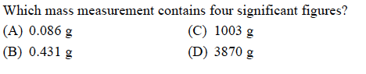

CLASS NOTES
1.4

How do we calculate using significant figures?

MULTIPLICATION/DIVISION:
- The number of significant figures are determined by the number that has the LEAST number of significant figures

SAMPLE QUESTIONS

- 93.4/12 =

- YOU TRY: 8.032 X 0.591 =

ADDITION/SUBTRACTION:
- The number of significant figures is determined by the number that has the LEAST number of the significant figures to the RIGHT of the decimal point.

- 7.623 + 85.0 + 9.815 =

- YOU TRY: 5.5 - 3.325 =

CLASS WORK
1.4

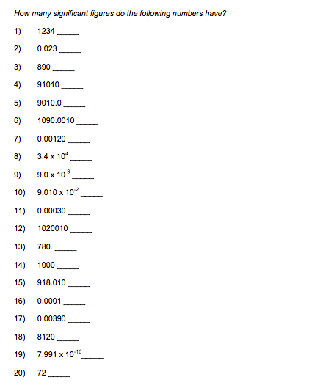

I
1.4
CLASS WORK

