Packet #2
UNIT 1:
Chemathematics

/ | Completed Class Notes
/ | Completed Classwork
/ | Completed Homework
/20 | Handed Packet in on Time
/ | Expectations Tracker
/ | Total Points
Comments:

Due Date: ____________________

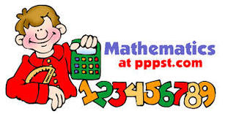

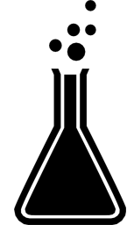

DAILY EXPECTATIONS TRACKER

To ensure EVERY student is doing what he/she needs to do,
I am holding you accountable to follow daily class expectations.

Following each expectation = 5 points
MAX # of points = 100 points

It is YOUR RESPONSIBILITY that Ms. Francois stamps/checks this by the end of the period.
You CANNOT get it any other time!!!!!

You will NOT receive a check if you did not follow all classroom policies or actively work on the practice problems during the allotted class time. Ms. Francois is the final judge about you following daily expectations.

 | Arrive on Time | Participation  in Class | Behavior | Classwork effort | Homework completion
Monday
Tuesday
Wednesday
Thursday
Friday

Table of contents

1.5 | Solving Density
1.6 | Solving Mass and Volume
1.7 | Precision and Accuracy
1.8 | Percent Error

Contact information

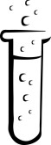
Email: pfrancois@hs-gc.org

Website: msfrancoischem.weebly.com

1.5
Aim:

Objective:

Real world connection:

Vocabulary: *Density * Mass * Volume *

CLASS NOTES

Defining Density

Which is heavier? A pound of paper or a pound of rocks? Why?

Think-Ink  Jot down your answer to the question. | Pair-Share  Write down what your other group members wrote down.

CLASS NOTES
1.5

Word | Definition
Mass

Volume

Density

Calculating Density

- Formula for Density can be found in Table ______ of the reference table

Formula for Density

1.5
CLASS NOTES

Suppose you have a gold ring that weights 7.50g and has a volume of 0.388 mL. What is the density of that gold ring?

F = ________________ | L = ____________________
P = ________________ | S = _____________________

2. If two objects have the same mass, what must be true? Choose the correct answer (s):

- They have the same volume
- They are made of the same material
- They contain the same amount of matter
- They have the same density

3. Which element has the greatest density at STP?
- calcium
- carbon
- chlorine
- copper

CLASS NOTES
1.5

YOU TRY:
Which element has the greatest density at STP?
- Scandium
- Silicon
- Selenium
- Sodium

Identifying Matter Using Density

- Each type of substance has a ________________ density.

- To find the density of an object, you can look at ____________________ of the reference table

Example:
Density of Gold: _________________________

Question: A shiny, gold-colored bar of metal weighing 57.3 g has a volume of 4.7cm³. Is the bar of metal pure gold? Explain your answer.

CLASS NOTES
1.5

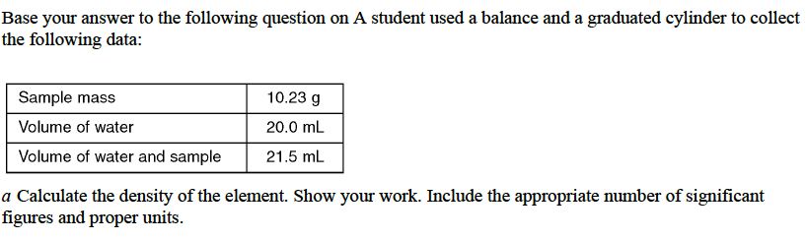

Summary: How can the density of an object be determined?

CLASS WORK
1.5

1. What is the density of an 84.7g sample of an unknown substance if the sample occupies 49.6cm³ of space?

F = ________________ | L = ____________________
P = ________________ | S = _____________________

2. Suppose you have a penny that has the mass of 2.6g and a volume of 0.36 cm³. Does it have the same density as two pennies together? Why or why not? Show work to prove your answer. Explain your answer.

CLASS WORK
1.5

3. You have a 35 ml solution with a mass of 43 grams. Will this solution float in water or not? Explain your reasoning and show your work. (Remember the density of water = 1 g/mL. Things float with a lower density than water and things sink with a higher density than water).

4. I want to create a density bottle with 3 solutions called A, B and C. I put 45 ml of solution A with a mass of 65 grams. I put 15 ml of solution B with a mass of 23 grams and I put 100 ml of solution C with a mass of 130 grams in a bottle. Calculate the densities of each and draw a model of how the 3 liquids will layer. Show all work.

1.6
Aim:

Objective:

Real world connection:

Vocabulary: *Density * Mass * Volume *

CLASS NOTES

Solving for Mass and Volume Using Density
Question solving for volume: The volume of dry air measured ay 25ºC is 1.9 x 10⁻³ cm³. What is the volume of air of 50.0g of air?

F = ________________ | L = ____________________
P = ________________ | S = _____________________

CLASS NOTES
1.6

Question solving for mass: The density of water is 1 g/ml. What mass does 30 ml of water have?

F = ________________ | L = ____________________
P = ________________ | S = _____________________

YOU TRY: You were given 10g cubes of lithium, aluminum, and lead. Using the reference table to find the density, solve for the volume of each element.

CLASS NOTES
1.6

YOU TRY continued: What happens to the volume if you now had 10g spheres of lithium, aluminum and lead? Explain AND show your reasoning.

Summary: How does solving for mass or volume differ from solving density?

CLASSWORK
1.6

Two objects each have a mass of 5.0g. One has a density of 2.7 g/cm³ and the other has a density of 8.4 g/cm³. Which object has a larger volume? Explain your thinking.

If the density of a diamond is 3.5 g/cm3, what would be the mass of a diamond whose volume is .5 cm³?

CLASSWORK
1.6

The density of a substance is 1.63 g/mL. What is the mass of 0.25 mL of the substance in grams?

What volume does 5g of copper occupy?

What is the mass of a 450 cm³ block of silicon?

1.7
Aim:

Objective:

Real world connection:

Vocabulary: *Precision * Accuracy *

CLASS NOTES

Step 1: Measure the left side of your desk with the top of your thumb. Top of your thumb = about 1 inch. How long is the side of the desk in inches? Do it 3 times.

Trial 1 | Trial 2 | Trial 3

Step 2: Measure side of desk with the ruler? How long is the side of the desk in inches? Do it 3 times.

Trial 1 | Trial 2 | Trial 3

Which form of measurement is a better form of measurement? Why?

CLASS NOTES
1.7

Defining Accuracy and Precision
Word | Definition
Accuracy

Precision

Precision vs. Accuracy Activity
Trial 1: Trial 2: Trial 3:

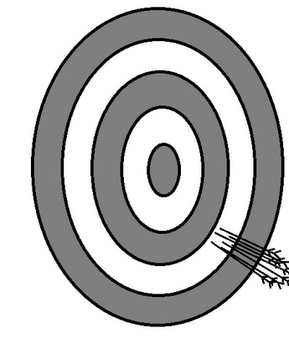
Accurate? ___________ Accurate? ___________ Accurate? ___________
Precise? _____________ Precise? _____________ Precise? _____________

Explain your reason for Trial 1:

Explain your reason for Trial 2:

Explain your reason for Trial 3:

CLASS NOTES
1.7

What is the most precise lab equipment?

- When measuring, the ___________________ the increments (tick marks), the more precise.
because ___________________________________________________________________________
_____________________________________________________________________________________

Choose which graduated cylinder will give you the most accurate reading? The most precise reading? Explain your reasoning.

Summary: What distinguishes accuracy from precision?

CLASS WORK
1.7

Scenario: A group of five friends are playing darts after school. Each group member shoots one dart.
Criteria: The group’s shooting is imprecise and inaccurate.
(Use the paper to draw a dartboard and darts. Make sure to explain why your picture depicts shooting that is imprecise and inaccurate).

Scenario: A group of five friends are playing darts after school. Each group member shoots one dart.
Criteria: The group’s shooting is precise and accurate.
(Use the paper to draw a dartboard and darts. Make sure to explain why your picture depicts shooting that is imprecise and inaccurate).

I
1.7
CLASS WORK

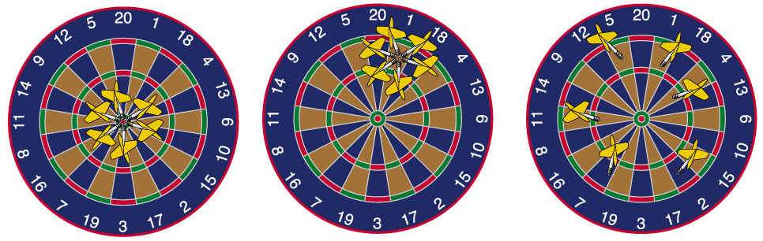

Label each dart by describing how accurate and precise each are.

A graduated cylinder with increments of .5mL and a graduated cylinder with increments of 0.1 mL. Which is more precise?

Which ruler is more precise? Explain your answer.
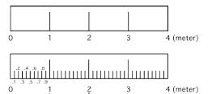

1.8
Aim:

Objective:

Real world connection:

Vocabulary: *Percent Error * Measure Value * Accepted Value *

CLASS NOTES

Looking at Error

- To evaluate error, we use the ___________________________ formula which is found in ______________________ of the reference table

Formula for Percent Error | *Answers must be positive & have % sign

Word | Definition
Measured value

Accepted value

CLASS NOTES
1.8

1. Alpha measured the boiling point of water to be 99.1ºC. Calculate the percent error.

F = ________________ | L = ____________________
P = ________________ | S = _____________________

2. A student measures the mass and volume of a piece of aluminum. The measurements are 25.6 grams and 9.1 cubic centimeters. The student calculates the density of the aluminum. What is the percent error of the student’s calculated density of aluminum?
a. | 1%
b. | 2%
c. | 3%
d. | 4%

CLASS NOTES
1.8

- Base your answer on A student used a balance and a graduated cylinder to collect the following data.
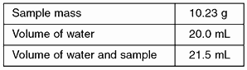

a Calculate the density of the element. Show your work.

b If the accepted value is 6.93 grams per milliliter, calculate the percent error.

CLASS WORK
1.8

1. A student takes an object with an accepted mass of 200.00 grams and masses it on his own balance. He records the mass of the object as 196.5 g. What is his percent error?

2. The experimentally obtained value for the melting point of a substance is 51.0ºC and the accepted value for the melting point of this same substance is 53.0 ºC. What is the percent error for this experimental value?

3. If the observed value for a density is 0.80 g/ml and the accepted value is 0.70 g/ml, what is the percent error?
a. | 0.17%
b. | 0.14%
c. | 17.%
d. | 14.%

I
1.8
CLASS WORK

4. A student found the boiling point of a liquid to be . If the liquid's actual boiling point is , the experimental percent error is equal to
a. | 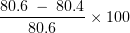
b. | 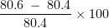
c. | 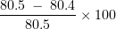
d. | 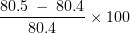

5. In an experiment the gram atomic mass of magnesium was determined to be 24.7. Compared to the accepted value 24.3, the percent error for this determination was
a. | 0.400
b. | 1.65
c. | 24.7
d. | 98.4

6. In an experiment, a student found 18.6% by mass of water in a sample of BaCl₂ • 2H₂O. The accepted value is 14.8%. What was the student's experimental percent error?
a. | 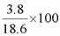
b. | 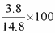
c. | 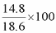
d. | 