5.1 Class Practice

THINK ABOUT IT!!!!
Potassium Atom | Potassium Ion
Potassium is the eighth most abundance element on the earth, but is never found free in nature.  Draw the Lewis dot diagram for potassium (K)  Number of protons:  Number of neutrons:  Number of electrons:  Electron configuration: | Potassium ions are necessary for the function of all living cells.  Draw the Lewis dot diagram for potassium ion (K+)  [K⁺]  Number of protons: 19  Number of neutrons: 20  Number of electrons: 18  Electron configuration: 2-8-8

GIVE IT A TRY! Determine the number of electrons needed to fulfill the octet rule. Circle whether it is easier to gain or lose electrons
Mg  Valence electrons:  Has to gain:  Has to lose: | Al  Valence electrons:  Has to gain:  Has to lose: | S  Valence electrons:  Has to gain:  Has to lose:

5.1 Class Practice

So elements can either gain OR lose electrons to reach stability. Let's look for patterns on the periodic table:

Li  Valence electrons:  Has to gain:  Has to lose: | Na  Valence electrons:  Has to gain:  Has to lose: | K  Valence electrons:  Has to gain:  Has to lose:
F  Valence electrons:  Has to gain:  Has to lose: | Cl  Valence electrons:  Has to gain:  Has to lose: | Br  Valence electrons:  Has to gain:  Has to lose:

Symbol | Cation or anion | More or less electrons than atom | Number of electrons gained/lost compared
Na⁺ | Cation | Less | Lost 1 electron
Al³⁺
S²⁻
Fe³⁺
Cu²⁺
Fe²⁺
O²⁻
N³⁻
Ni²⁺

5.1 Class Work

SAMPLE QUESTIONS:
What is the total number of valence electrons in an ion of boron in the ground state?
A) 8 B) 2 C) 5 D) 3

Which particle has the same electron configuration as a calcium ion?
A) fluoride ion B) sodium ion C) potassium atom D) argon atom

What is the net charge of an ion that has 13 protons, 12 neutrons, and 10 electrons?
A) +1 B) +3 C) -1 D) -3

Which electron configuration is correct for a sodium ion?
- 2–7 B) 2–8 C) 2–8–1 D) 2–8–2

Compared to a calcium atom, the calcium ion Ca²⁺ has
- more protons B) fewer protons C) more electrons D) fewer electrons

CLASS WORK QUESTIONS
Question | Key Words/Explain Answer
What is the total number of valence electrons in an ion of sulfur in the ground state?  A) 8  B) 2  C) 16  D) 18 | KEY WORDS AND SYMBOLS:  EXPLANATION:  ________________________________________________  ________________________________________________  ________________________________________________  ________________________________________________
An atom of an element forms a 2⁺ ion. In which group on the Periodic Table could this element be located?  A) 1  B) 2  C) 13  D) 17 | KEY WORDS AND SYMBOLS:  EXPLANATION:  ________________________________________________  ________________________________________________  ________________________________________________

5.1 Class Work

What is the total number of electrons in a Mg²⁺ ion?  A) 10  B) 12  C) 14  D) 24 | KEY WORDS AND SYMBOLS:  EXPLANATION:  ________________________________________________  ________________________________________________  ________________________________________________  ________________________________________________
What is the net charge on an ion that has 9 protons, 11 neutrons, and 10 electrons?  A) 1+  B) 2+  C) 1-  D) 2- | KEY WORDS AND SYMBOLS:  EXPLANATION:  ________________________________________________  ________________________________________________  ________________________________________________  ________________________________________________
Which particle has the same electron configuration as a potassium ion?  A) fluoride ion  B) sodium ion  C) neon atom  D) argon atom | KEY WORDS AND SYMBOLS:  EXPLANATION:  ________________________________________________  ________________________________________________  ________________________________________________  ________________________________________________
When metals form ions, they tend to do so by  - losing electrons and forming positive ions  - losing electrons and forming negative ions  - gaining electrons and forming positive ions  - gaining electrons and forming negative ions | KEY WORDS AND SYMBOLS:  EXPLANATION:  ________________________________________________  ________________________________________________  ________________________________________________

CATALYST ACTIVITY Part 1: CATIONS
5.2 Class Notes
- How many electron shells does sodium have? _________

- How many electron shells does the sodium ion have? _________
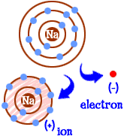
How do you think the atomic radius of sodium will compare to the ionic radius of a sodium
ion? Defend your answer based from the picture and what you know about cations.

How does the ionic radius compare to the atomic radius for Cations?
- Quick Review: How are cations formed? _______________________________________________________________________________________________________________________________________________________________________________________________________________________________________________

Use Table S to compare the ionic radius of three cations with the atomic radius of the parent atom
 | Ionic radius | Atomic radius
K+ vs. K | 152 pm
Mg²⁺ vs. Mg | 86 pm
Al³⁺ vs. Al | 68 pm

5.2 Class Notes

CATALYST ACTIVITY Part 2: ANIONS
- How many electrons does chlorine have? _________

- How many electrons does a chlorine ion have? _________
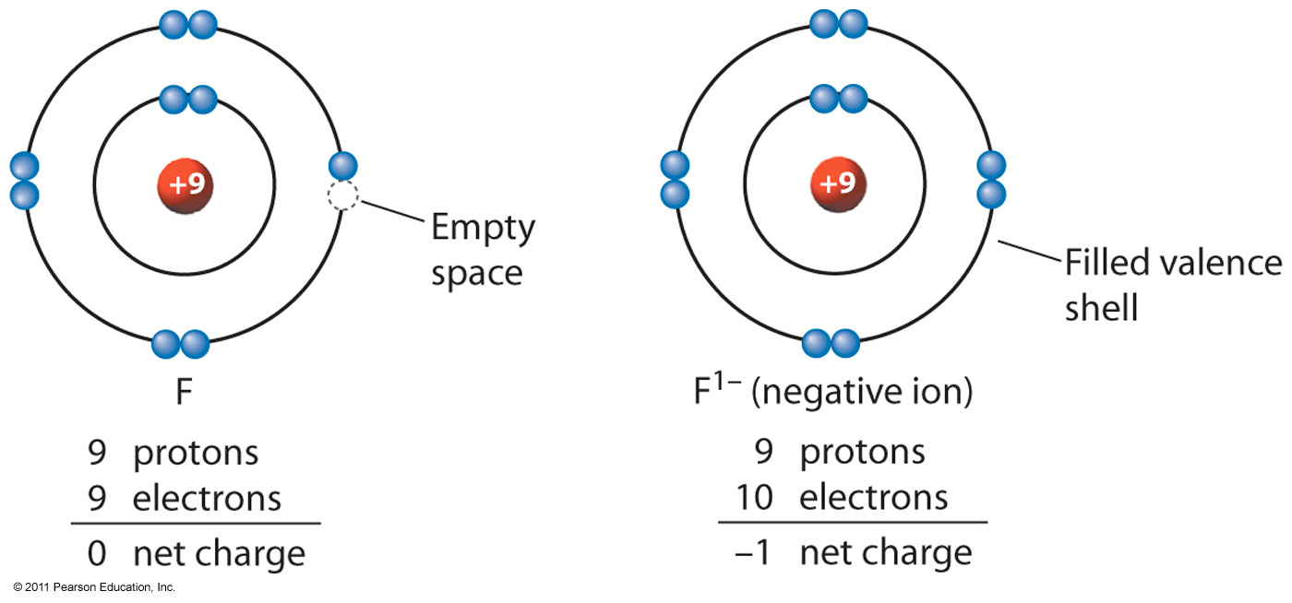
If electrons are negatively charged and negative charges repel each other, how will the atomic radius of chlorine compare with the ionic radius of a chlorine ion?

How does the ionic radius compare to the atomic radius for Anions?
- Quick Review: How are anions formed? ________________________________________________________________________________________________________________________________________________________________________________________________________________________________________________

Use Table S to compare the ionic radius of three anions with the atomic radius of the parent atom
 | Ionic radius | Atomic radius
F⁻ vs. F | 119 pm
O²⁻ vs. O | 126 pm
Se²⁻ vs. Se | 184 pm

5.2 Class Work

Parent Atom | Ion formed | Which has a larger radius (ion or atom) | Parent Atom | Ion formed | Which has a larger radius (ion or atom)
N |  |  | I
Br |  |  | Li
Sr |  |  | S
Ca |  |  | Rb

An ion of which element has a larger radius than an atom of the same element?  A) aluminum  B) chlorine  C) magnesium  D) sodium | KEY WORDS AND SYMBOLS:  EXPLANATION:  ________________________________________________  ________________________________________________  ________________________________________________
Which of the following ions has the smallest radius?  A) F–  B) Cl–  C) K+  D) Ca²⁺ | KEY WORDS AND SYMBOLS:  EXPLANATION:  ________________________________________________  ________________________________________________  ________________________________________________
An atom with the electron configuration 2-8-2 would most likely  A) decrease in size as it forms a positive ion  B) increase in size as it forms a positive ion  C) decrease in size as it forms a negative ion  D) increase in size as it forms a negative ion | KEY WORDS AND SYMBOLS:  EXPLANATION:  ________________________________________________  ________________________________________________  ________________________________________________
How does the size of a barium ion compare to the size of a barium atom?  A) The ion is smaller because it has fewer electrons.  B) The ion is smaller because it has more electrons.  C) The ion is larger because it has fewer electrons.  D) The ion is larger because it has more electrons. | KEY WORDS AND SYMBOLS:  EXPLANATION:  ________________________________________________  ________________________________________________  ________________________________________________

5.2 Class Work

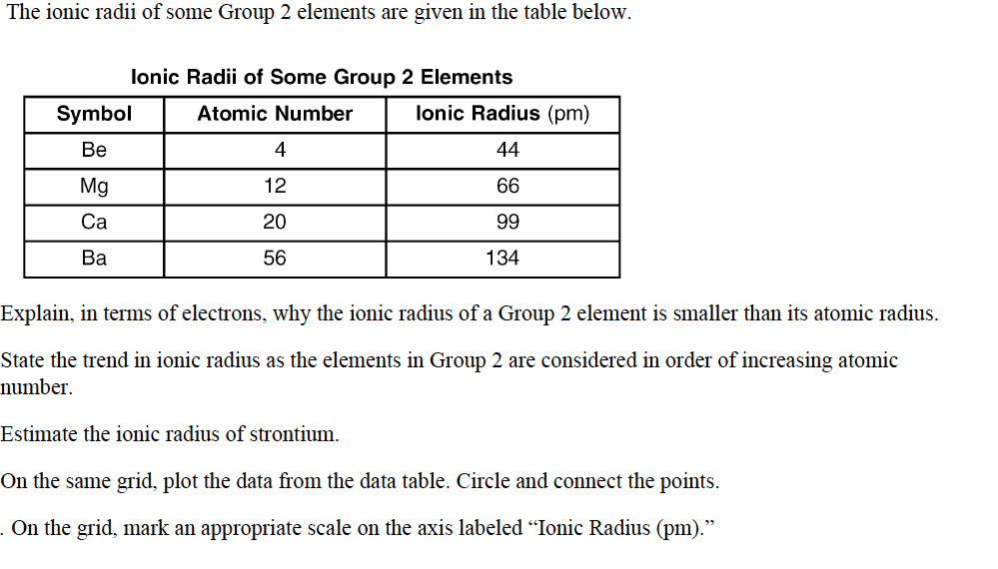

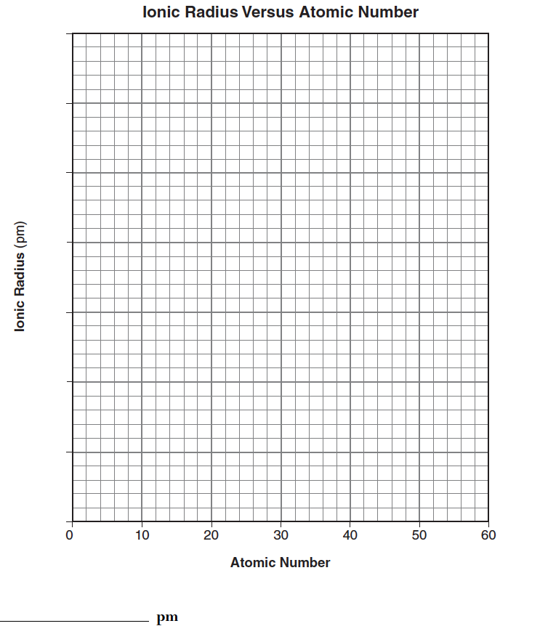

5.3 Class Work

- In which compound have electrons been transferred to the oxygen atom?  - CO₂  - NO₂  - N₂O  - Na₂O | KEY WORDS AND SYMBOLS:  EXPLANATION:  ________________________________________________  ________________________________________________  ________________________________________________
- Which formula represents a molecular substance?  - CaO  - CO  - Li₂O  - Al₂O₃ | KEY WORDS AND SYMBOLS:  EXPLANATION:  ________________________________________________  ________________________________________________  ________________________________________________
- Metallic bonding occurs between atoms of  - sulfur  - copper  - fluorine  - carbon | KEY WORDS AND SYMBOLS:  EXPLANATION:  ________________________________________________  ________________________________________________  ________________________________________________
- Which statement best describes the substance that results when electrons are transferred from a metal to a nonmetal?  - It contains ionic bonds and has a low melting point.  - It contains ionic bonds and has a high melting point.  - It contains covalent bonds and has a low melting point.  - It contains covalent bonds and has a high melting point. | KEY WORDS AND SYMBOLS:  EXPLANATION:  ________________________________________________  ________________________________________________  ________________________________________________

5.3 Class Work

- Which substance contains metallic bonds?  - Hg(l)  - H₂O(l)  - NaCl(s) | KEY WORDS AND SYMBOLS:  EXPLANATION:  ________________________________________________  ________________________________________________  ________________________________________________
- The bonds in the compound MgSO₄ can be described as  - ionic, only  - covalent, only  - both ionic and covalent  - neither ionic nor covalent | KEY WORDS AND SYMBOLS:  EXPLANATION:  ________________________________________________  ________________________________________________  ________________________________________________
- Which characteristic is a property of molecular substances?  - good heat conductivity  - good electrical conductivity  - low melting point  - high melting point | KEY WORDS AND SYMBOLS:  EXPLANATION:  ________________________________________________  ________________________________________________  ________________________________________________

PRACTICE!
Directions: For each element, write down their location on the periodic table by group and period and then classify them as metal, metalloid, or non-metal.

Compound/Element | Ionic, Covalent, Metallic
Au
NaBr
AlP
SO₂
Ag
N₂O₃

5.4 Class Work

YOU TRY! FORMULAS FOR IONIC BONDS
What is the ionic bond that is formed between Li and F?

What is the ionic bond that is formed between K and O?

What is the ionic bond that is formed between Ba and Cl?

What is the ionic bond that is formed between K and F?

What is the ionic bond that is formed between S and O?

YOU TRY! NAMING FOR IONIC BONDS
BeCl₂ ___________________________________

MgBr₂ ________________________________________________________

KCl ___________________________________

LiF ___________________________________

CaO ___________________________________
5.4 Class Work

TRANSITION METALS: Take a Look!
- Iron (Fe) can sometimes lose 2 electrons and sometimes lose 3 electrons.
  - Iron that loses 2 electrons has this charge. _________________
  - Iron that loses 3 electrons has this charge. _________________

Here is a list of transition metals that can form multiple ions.
Ion Symbol  Are you noticing a trend? | Ion Name | Ion Symbol | Ion Name
Cu⁺ | Copper(I) ion | Sn²⁺ | Tin(II) ion
Cu²⁺ | Copper(II) ion | Sn⁴⁺ | Tin(IV)
Fe²⁺ | Iron(II) ion | Cr²⁺ | Chromium(II) ion
Fe³⁺ | Iron(III) ion | Cr³⁺ | Chromium(III) ion
Hg₂²⁺ | Merury(I) ion | Mn²⁺ | Manganese(II) ion
Hg²⁺ | Mercury(II) ion | Mn³⁺ | Manganese(III) ion
Pb²⁺ | Lead(II) ion | Co²⁺ | Cobalt(II) ion
Pb⁴⁺ | Lead(IV) ion | Co³⁺ | Cobalt(III) ion

Try it on your own! Write name or formula.
- Copper(I) and Fluorine:  - Mercury(II) and Oxygen:  - Lead (II) and Sulfur: | - CrBr₂  - Co₂S₃  - PbO

5.4 Class Work

BOND WITH A CLASSMATE!
- Hello, my name is ___________________________________
- My symbol is _______________________ My charge is ________________________
- I am cation/ anion (circle one) I am gain/lose (circle one) this many electrons ________________
- I am a metal/ nonmetal (circle one) I need/ do not need a middle name (THINK IF IT'S A TRANSITION METAL)

Cation | Anion | Compound | Name
Ca⁺² | N³⁻ | Ca₃N₂ | Calcium nitride

5.4 Class Work

What is the correct formula for a compound of Li and F?  (1) LiF  (2) Li₂F  (3) LiF₂  (4) Li₂F₃ | KEY WORDS AND SYMBOLS:  EXPLANATION:  ________________________________________________  ________________________________________________  ________________________________________________  ________________________________________________
What is the correct formula for a compound of Al and O?  (1) AlO  (2) Al₂O  (3) Al₃O₂  (4) Al₂O₃ | KEY WORDS AND SYMBOLS:  EXPLANATION:  ________________________________________________  ________________________________________________  ________________________________________________  ________________________________________________
What is the correct formula for a compound of Ca and Br?  (1) CaBr  (2) Ca₂Br  (3) CaBr₂  (4) Ca₂Br₃ | KEY WORDS AND SYMBOLS:  EXPLANATION:  ________________________________________________  ________________________________________________  ________________________________________________
What is the correct formula for a compound of Al and P?  (1) AlP  (2) Al₂P  (3) AlP₂  (4) Al₂P₃ | KEY WORDS AND SYMBOLS:  EXPLANATION:  ________________________________________________  ________________________________________________  ________________________________________________  ________________________________________________

5.4 Class Work

Question | Key Words/Explain Answer
- In which compound have electrons been transferred to the oxygen atom?  - CO₂  - NO₂  - N₂O  - Na₂O | KEY WORDS AND SYMBOLS:  EXPLANATION:  ________________________________________________  ________________________________________________  ________________________________________________  ________________________________________________
- Which formula represents an ionic compound?  - NaCl  - N₂O  - HCl  - H₂O | KEY WORDS AND SYMBOLS:  EXPLANATION:  ________________________________________________  ________________________________________________  ________________________________________________  _______________________________________________
- Which elements combine by forming an ionic bond?  - sodium and potassium  - sodium and oxygen  - carbon and oxygen  - carbon and sulfur | KEY WORDS AND SYMBOLS:  EXPLANATION:  ________________________________________________  ________________________________________________  ________________________________________________  ________________________________________________
- A barium atom attains a stable electron configuration when it bonds with  - one chlorine atom  - two chlorine atoms  - one sodium atom  - two sodium atoms | KEY WORDS AND SYMBOLS:  EXPLANATION:  ________________________________________________  ________________________________________________  ________________________________________________  ________________________________________________

5.4 Class Work

MORE PRACTICE:

WRITING FORMULAS:
 | Cl⁻ | O²⁻ | S²⁻ | N⁻³ | F⁻
Na⁺ | NaCl
Ba⁺² | BaCl₂
Al³⁺
Sn⁴⁺

WRITING FORMULAS:
- 1) gallium selenide __________________________________
- 2) strontium iodide __________________________________
- 3) titanium (IV) fluoride ______________________________
- 4) zinc hydride _____________________________________
- 5) platinum (II) arsenide _______________________________

WRITING NAMES:
1) TiSe __________________________________
2) Cu2O _________________________________
3) V3P5 __________________________________
4) Zn3N2 _________________________________
5) PbS __________________________________

5.5 Class Notes
YOU TRY!
Example #1: P₂O5 ____________________________________________
 | # of atoms | Prefix | Name
1st atom
2nd atom |  |  |  | (add -ide)

Example #2: N₂O4 _____________________________________________
 | # of atoms | Prefix | Name
1st atom
2nd atom |  |  |  | (add -ide)

Chemical Formula | Name
CO
N₂O₃
N₂O₅
CCl₄
NI₃
CBr₄
SO₂
PCl₃

5.5 Class Work
YOU TRY!
Example #1: Diphosphorus trioxide
Formula of compound: _____________________________________

Example #2: Carbon tetrachloride
Formula of compound: _____________________________________

Write the formulas for the following covalent compounds:
a) diboron hexahydride ____________________________________
b) nitrogen tribromide ______________________________________
c) sulfur hexachloride ______________________________________
d) diphosphorus pentoxide __________________________________

SAMPLE QUESTIONS
Question | Explanation of Answer
Which substance contains bonds that involved the sharing of electrons from one atom to another?  A) Calcium and iodine  B) hydrogen and nitrogen  C) barium and bromine  D) boron and bromine | KEY WORDS AND SYMBOLS:  EXPLANATION:  ________________________________________________  ________________________________________________  ________________________________________________  ________________________________________________
Which formula represents a molecular substance?  - CaO  - CO  - Li₂O  - Al₂O₃ | KEY WORDS AND SYMBOLS:  EXPLANATION:  ________________________________________________  ________________________________________________  ________________________________________________

5.5 Class Work

COVALENT WORKSHEET:

Name the following covalent compounds:

a) SiF₄ __________________________________________________

b) N₂S₃ _________________________________________________

c) HBr __________________________________________________

d) P₄S₅ __________________________________________________

e) SeF₆ __________________________________________________

f) Si₂Br₆ _________________________________________________

g) SCl₄ __________________________________________________

h) B₂Si __________________________________________________

Write the formulas for the following covalent compounds:

a) diboron hexahydride ____________________________________

b) nitrogen tribromide ______________________________________

c) sulfur hexachloride ______________________________________

d) diphosphorus pentoxide __________________________________

e) antimony tribromide ____________________________________

f) hexaboron silicide ______________________________________

g) chlorine dioxide _______________________________________

h) hydrogen iodide _______________________________________

i) iodine pentafluoride ____________________________________

j) dinitrogen trioxide ______________________________________

k) phosphorus triiodide iodide _______________________________

5.5 Class Work

Question | Explanation of Answer
What is the name of the compound As₂O₅?  (1) Arsenic oxide  (2) Diarsenic oxide  (3) Diarsenic pentoxide  (4) Arsenic pentoxide | KEY WORDS AND SYMBOLS:  EXPLANATION:  ____________________________________________________  ____________________________________________________  ____________________________________________________  ____________________________________________________
What is the chemical formula for dinitrogen trioxide?  (1) NO  (2) N₃O₂  (3) N₂O₃  (4) NO₃ | KEY WORDS AND SYMBOLS:  EXPLANATION:  ________________________________________________  ________________________________________________  ________________________________________________  ________________________________________________
A molecular compound is formed when a chemical reaction occurs between atoms of  A) chlorine and sodium  B) chlorine and yttrium  C) oxygen and hydrogen  D) oxygen and magnesium | KEY WORDS AND SYMBOLS:  EXPLANATION:  ____________________________________________________  ____________________________________________________  ____________________________________________________  ____________________________________________________
As a bond between a hydrogen atom and a sulfur atom is formed, electrons are  A) shared to form an ionic bond  B) shared to form a covalent bond  C) transferred to form an ionic bond  D) transferred to form a covalent bond | KEY WORDS AND SYMBOLS:  EXPLANATION:  ________________________________________________  ________________________________________________  ________________________________________________  ________________________________________________
5.6 Class Work

NAME FORMULA
- Sodium and Nitrate:

- Lithium and Cyanide:

- Magnesium and Chromate:

FORMULA NAME

- K₂SO₄

- (NH₄)₂SO₄

- Al₂(CO₃)₃

5.6 Class Work

SAMPLE REGENTS QUESTIONS
Which formula correctly represents the compound calcium hydroxide?  A) CaOH  B) Ca2OH  C) CaOH2  D) Ca(OH)2 | KEY WORDS AND SYMBOLS:  EXPLANATION:  ________________________________________________  ________________________________________________  ________________________________________________
Which is the formula for sodium perchlorate?  A) NaClO  B) NaClO2  C) NaClO3  D) NaClO4 | KEY WORDS AND SYMBOLS:  EXPLANATION:  ________________________________________________  ________________________________________________  ________________________________________________
Which formula correctly represents the compound In the formula X₂(SO₄)₃, the X represents a metal. This metal could be located on the Periodic Table in  (1) Group 1 (3) Group 13  (2) Group 2 (4) Group 14 | KEY WORDS AND SYMBOLS:  EXPLANATION:  ________________________________________________  ________________________________________________  ________________________________________________
Which formula represents strontium phosphate?  (1) SrPO₄ (3) Sr₂(PO₄)₃  (2) Sr₃PO₈ (4) Sr₃(PO₄)₂ | KEY WORDS AND SYMBOLS:  EXPLANATION:  ________________________________________________  ________________________________________________  ________________________________________________

Explain one similarity and one difference between a sulfur ion and a sulfate ion.

5.6 Class Work

Write the formulas for the following compounds:
- Sodium chlorate: ______________________
- Strontium sulfate: _____________________
- Ammonium iodide : ____________________
- Indium hydroxide: _____________________
- Calcium acetate: ______________________
- Calcium perchlorate: ______________________
- Lithium carbonate: _____________________
- Aluminum sulfate : ____________________
- Ammonium nitrate: _____________________
- Magnesium hydrogen sulfate: _____________________
Write names for the following polyatomic compounds:
- NaCrO2 __________________________________________
- Sr(HSO3)2 __________________________________________
- K4(P2O7) __________________________________________
- LiMnO4 __________________________________________
- CaCr2O7 __________________________________________
- Ba (CN)₂ __________________________________________
- Mg₃(PO₄)₂ __________________________________________
- NH₄NO₂ __________________________________________
- Mg(OH)₂ __________________________________________
- Na₂CrO₄ __________________________________________

