5.7 Class Work

Draw the Lewis Dot Structure for the following: Using checklist from packet
HI | PCl₃ | SCl₂
Check partner’s work | Check partner’s work | Check partner’s work
Successful diagram checklist!  - Every element has eight valence electrons except for hydrogen and helium, which will only have 2 valence electrons.  - Each line (bond) represents two electrons  - Each dot represents one electron  - It adds up to total # of valence electrons needed  In order to fix your Lewis Dot Diagram you must: | Successful diagram checklist!  - Every element has eight valence electrons except for hydrogen and helium, which will only have 2 valence electrons.  - Each line (bond) represents two electrons  - Each dot represents one electron  - It adds up to total # of valence electrons needed  In order to fix your Lewis Dot Diagram you must: | Successful diagram checklist!  - Every element has eight valence electrons except for hydrogen and helium, which will only have 2 valence electrons.  - Each line (bond) represents two electrons  - Each dot represents one electron  - It adds up to total # of valence electrons needed  In order to fix your Lewis Dot Diagram you must:

5.7 Class Work
Draw the Lewis Dot Structure for the following: Using checklist from packet

NI₃ | SiCl₄ | PF₃

Sample Regents Questions:: Base your answer to the following question on the information below.
Bromine is the only liquid nonmetallic element at room temperature. It is a heavy, mobile, reddish-brown liquid, volatilizing readily at room temperature to a red vapor with a strong disagreeable odor, resembling chlorine, and having a very irritating effect on the eyes and throat; it is readily soluble in water or carbon disulfide, forming a red solution, is less active than chlorine but more so than iodine; it unites readily with many elements and has a bleaching action; when spilled on the skin it produces painful sores. It presents a serious health hazard & maximum safety precautions should be taken when handling it.
- Draw the electron-dot diagram of a molecule of bromine, Br2.
- Why does bromine have properties resembling chlorine?

Draw a correct Lewis electron-dot structure for each of the following.
a) An atom of hydrogen
b) An atom of nitrogen
c) A molecule of ammonia (NH₃)
5.8 Class Work

TRY ON YOUR OWN:
Draw the Lewis Dot Structure of hydrogen cyanide. Formula: ________________

Draw the Lewis Dot structure of Carbon Dioxide. Formula: ___________________

Draw the Lewis Dot structure of Carbon Monoxide. Formula:__________________

Describe two ways that carbon dioxide and carbon monoxide differ.

5.8 Class Work

Question | Explanation of Answer
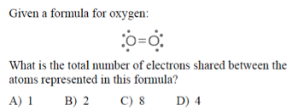 | KEY WORDS AND SYMBOLS:  EXPLANATION:  ________________________________________________  ________________________________________________  ________________________________________________  ________________________________________________
What is the total number of electrons shared in the bonds between the two carbon atoms in a molecule of ?  - 6  - 2  - 3  - 8 | KEY WORDS AND SYMBOLS:  EXPLANATION:  ________________________________________________  ________________________________________________  ________________________________________________  ________________________________________________
Which Lewis electron-dot diagram is correct for CO₂?  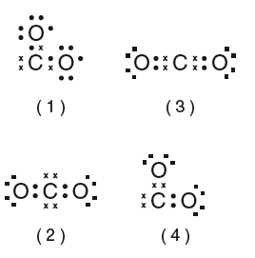 | KEY WORDS AND SYMBOLS:  EXPLANATION:  ________________________________________________  ________________________________________________  ________________________________________________  ________________________________________________
Which element has atoms that can form single, double, and triple covalent bonds with other atoms of the same element?  (1) hydrogen (2) oxygen  (3) fluorine (4) carbon | KEY WORDS AND SYMBOLS:  EXPLANATION:  ________________________________________________  ________________________________________________  ________________________________________________  ________________________________________________

5.9 Class Work

PART 1: POLAR & NONPOLAR BONDS
Which of the following compounds contains a nonpolar covalent bond?  A) CCl₄  B) NaBr  C) HF  D) Br₂ | KEY WORDS AND SYMBOLS:  YOUR EXPLANATION:  ________________________________________________  ________________________________________________  _______________________________________________  PARTNER CHOICE: ____________________  PARTNER EXPLANATION:  ________________________________________________  ________________________________________________  _______________________________________________
Which of the following does not a nonpolar covalent bond?  A) N₂  B) H₂O  C) O₂  D) CaI₂ | KEY WORDS AND SYMBOLS:  EXPLANATION:  ________________________________________________  ________________________________________________  ________________________________________________  PARTNER CHOICE: ____________________  PARTNER EXPLANATION:  ________________________________________________  ________________________________________________  _______________________________________________
5.9 Class Work
For the following, state whether it is a nonpolar or polar covalent bond. State whether or not it has a dipole moment. If it does, draw the direction of the dipole moment.

Bond | Non Polar/Polar | Dipole Moment
Br₂
HCl
SO
NO
NH
CN
O₂

PART 2: POLAR & NONPOLAR COMPOUNDS

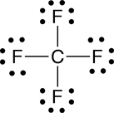  a)  ________________________ molecule __________________________ bonds | Why?
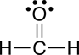  b) ________________________ molecule __________________________ bonds | Why?
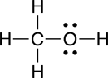  c) ____________________ molecule __________________________ bonds | Why?
5.9 Class Work

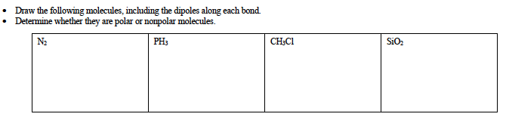
Circle one and explain reason for choice

N₂: Polar Molecule or NonPolar Molecule

Why? ____________________________________________________________________________________________

PH₃: Polar Molecule or NonPolar Molecule

Why? ____________________________________________________________________________________________

CH₃Cl: Polar Molecule or NonPolar Molecule

Why? ____________________________________________________________________________________________

SiO₂: Polar Molecule or NonPolar Molecule

Why? ____________________________________________________________________________________________

5.9 Class Work

SAMPLE QUESTION | EXPLANATION
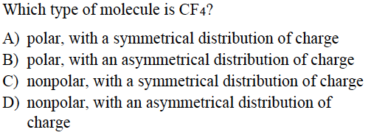 | KEY WORDS AND SYMBOLS:  EXPLANATION:  ________________________________________________  ________________________________________________  ________________________________________________
Which substance is correctly paired with its type of bonding?  A) NaBr–nonpolar covalent  B) HCl–nonpolar covalent  C) NH3–polar covalent  D) Br2–polar covalent | KEY WORDS AND SYMBOLS:  EXPLANATION:  ________________________________________________  ________________________________________________  ________________________________________________
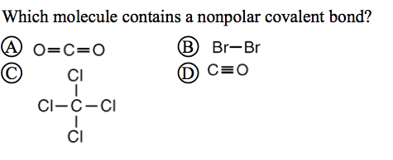 | KEY WORDS AND SYMBOLS:  EXPLANATION:  ________________________________________________  ________________________________________________  ________________________________________________
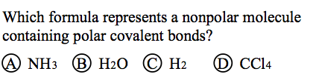 | KEY WORDS AND SYMBOLS:  EXPLANATION:  ________________________________________________  ________________________________________________  ________________________________________________

5.10 Class Work

SAMPLE REGENTS QUESTIONS
Which molecule is the most polar?  A) H₂O  B) H₂S  C) H₂Se  D) H₂Te | KEY WORDS AND SYMBOLS:  YOUR EXPLANATION:  ________________________________________________  ________________________________________________  _______________________________________________
Which compound has molecules that form the strongest bonds?  A) NaI  B) NaBr  C) NaF  D) NaCl | KEY WORDS AND SYMBOLS:  EXPLANATION:  ________________________________________________  ________________________________________________  ________________________________________________  PARTNER CHOICE: ____________________  PARTNER EXPLANATION:  ________________________________________________  ________________________________________________  _______________________________________________
Which of the following has the lowest boiling point?  A) H₂O  B) H₂S  C) H₂Se  D) H₂Te | KEY WORDS AND SYMBOLS:  EXPLANATION:  ________________________________________________  ________________________________________________  ________________________________________________  PARTNER CHOICE: ____________________  PARTNER EXPLANATION:  ________________________________________________  ________________________________________________  _______________________________________________

5.10 Class Work

For each of the following pairs of molecules, determine which is most polar and explain your reason for making this choice:

1) carbon disulfide OR sulfur difluoride

2) nitrogen trichloride OR oxygen dichloride

3) boron trihydride OR ammonia

Explain, in terms of electronegativity difference, why the bond in a molecule of HF is more polar than the bond in a molecule of HI.

Explain, in terms of electronegativity, why a P–Cl bond in a molecule of PCl₅ is more polar than a P–S bond in a molecule of P₂S₅.

Arrange the following in order of increasing bond strength. Explain why.

C-O C-H C-N C-C C-S C-Cl

5.10 Class Work

SAMPLE REGENTS QUESTIONS
In which liquid is hydrogen bonding the most significant force of attraction?  - HF (C) HBr  - HCl (D) HI | KEY WORDS AND SYMBOLS:  YOUR EXPLANATION:  ________________________________________________  ________________________________________________  _______________________________________________
Hydrogen bonding between molecules occurs when hydrogen is covalently bonded to elements that have  - High electro negativities and small atomic radii  - High electro negativities and large atomic radii  - Low electro negativities and small atomic radii  - Low electro negativities and large atomic radii | KEY WORDS AND SYMBOLS:  EXPLANATION:  ________________________________________________  ________________________________________________  ________________________________________________  PARTNER CHOICE: ____________________  PARTNER EXPLANATION:  ________________________________________________  ________________________________________________  _______________________________________________
Which atom has the least attraction for the electrons in a bond between that atom and an atom of hydrogen?  - Carbon (C) nitrogen  - Oxygen (D) fluorine | KEY WORDS AND SYMBOLS:  EXPLANATION:  ________________________________________________  ________________________________________________  ________________________________________________  PARTNER CHOICE: ____________________  PARTNER EXPLANATION:  ________________________________________________  ________________________________________________  _______________________________________________

5.10 Class Work

