Aim:
2.6

Objective:

Real world connection:

Vocabulary:

Let’s watch a video
3-2-1 Protocol for BrainPop Video
3 Things you learned from the video
1.

2.

3.

2 Questions You Have
1.

2.

1 Connection to Chemistry or Real Life
1.

2.6 Class Notes

 | SOLID | LIQUID | GAS
Definite shape?
Definite volume?
Notation/ Symbol
Particle Diagram
Intermolecular Forces

TERM | DEFINITION
Intermolecular forces | Prefix:  Suffix:

2.6 Class Notes
SOLIDS
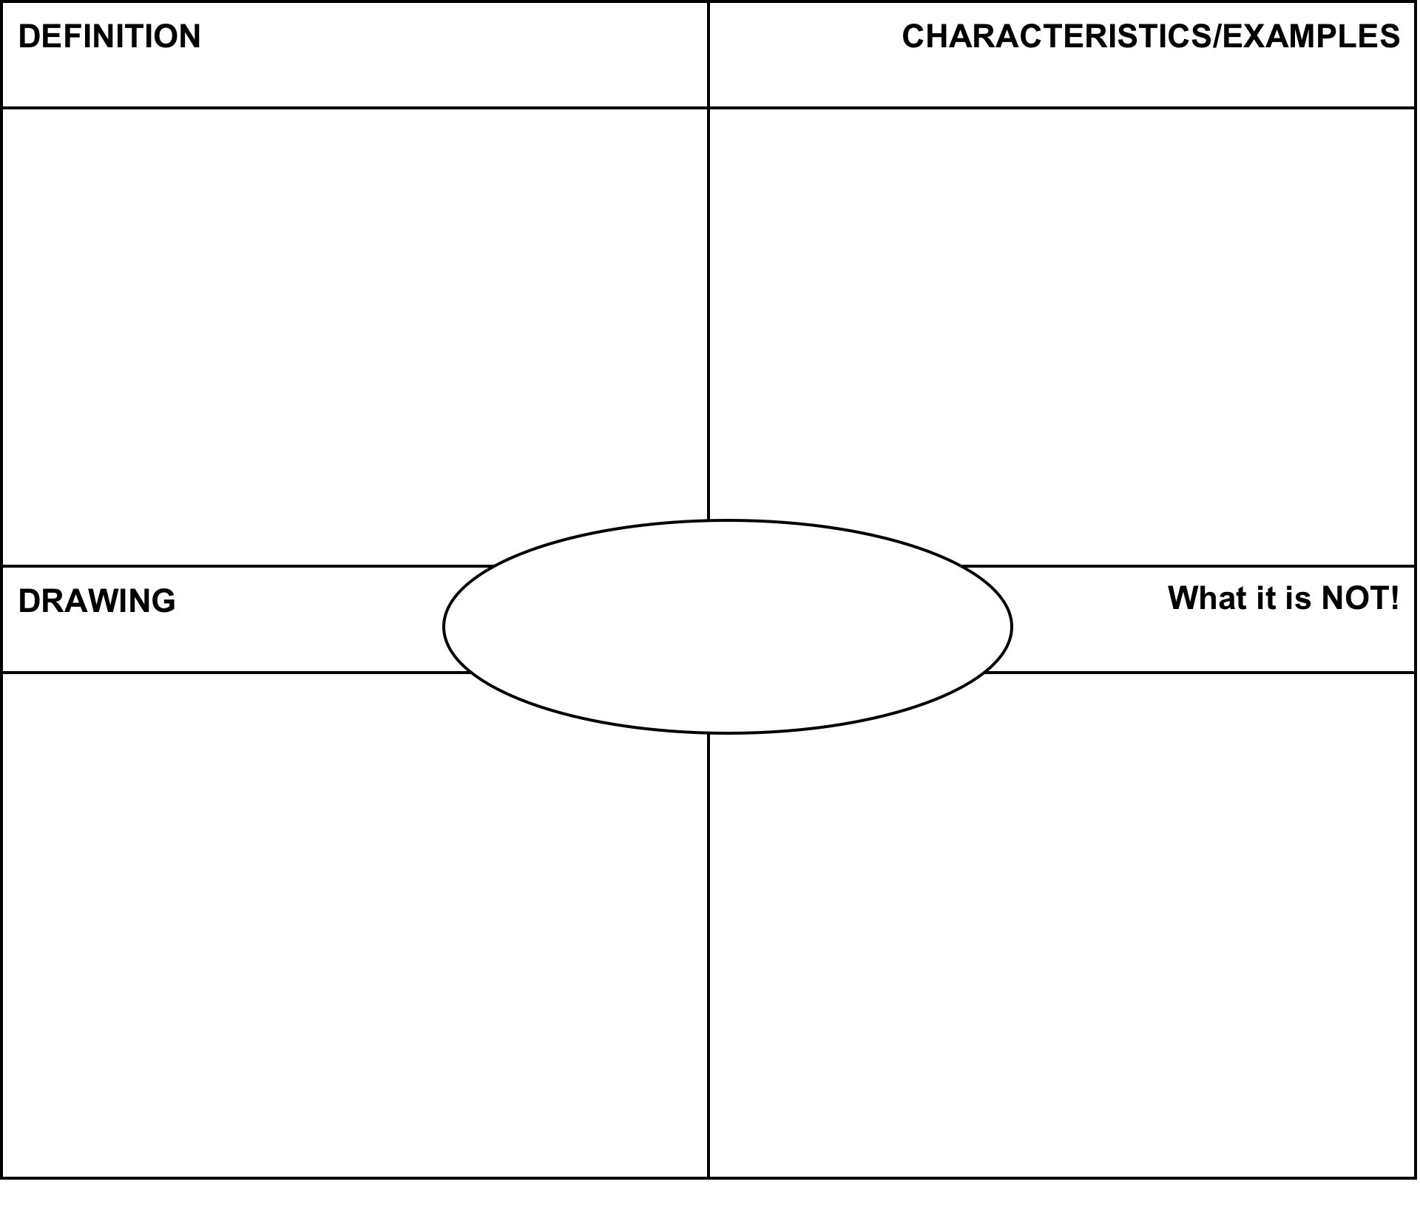
LIQUIDS

2.6 Class Notes
GASES
Question | Explanation of Answer
- Which statement best describes the molecules of AlCl₃ (s)?  - They move slowly in straight lines  - They move rapidly in straight lines  - They are arranged in a random pattern  - They are arranged in a regular pattern | KEY WORDS AND SYMBOLS:  EXPLANATION:  ________________________________________________  ________________________________________________  ________________________________________________
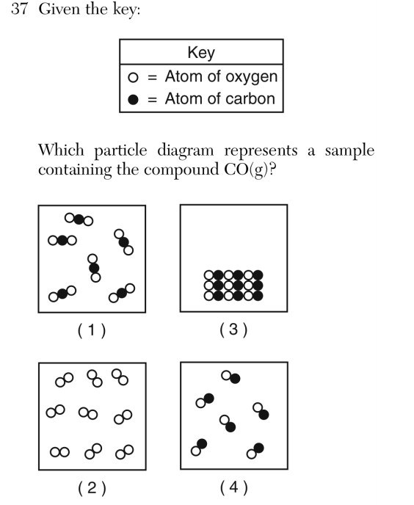  - Given the key:  Which particle diagram represents a sample containing the compound CO(g)? | KEY WORDS AND SYMBOLS:  EXPLANATION:  ________________________________________________  ________________________________________________  ________________________________________________  ________________________________________________  ________________________________________________

2.6 Class Work

Question | Explanation of Answer
- Draw a particle model showing at least six particles for a solid and gas using the key below:  One particle  Solid  Gas | KEY WORDS AND SYMBOLS:  EXPLANATION:  ________________________________________________  ________________________________________________  ________________________________________________  ________________________________________________  ________________________________________________
- Which set of properties does a substance such as CO_{2 (g)} have?  - definite shape and definite volume  - definite shape but no definite volume  - no definite shape but definite volume  - no definite shape and no definite volume | KEY WORDS AND SYMBOLS:  EXPLANATION:  ________________________________________________  ________________________________________________  ________________________________________________  ________________________________________________
- Which substance has a definite shape and a definite volume at STP?  - NaCl (aq)  - Cl₂ (g)  - CCl₄ (l)  - AlCl₃ (s) | KEY WORDS AND SYMBOLS:  EXPLANATION:  ________________________________________________  ________________________________________________  ________________________________________________
- As a substance changes from a liquid to a gas, the average distance between molecules  - decreases  - increases  - remains the same  - none of the above | KEY WORDS AND SYMBOLS:  EXPLANATION:  ________________________________________________  ________________________________________________  ________________________________________________  ________________________________________________

2.6 Class Work

Question | Explanation of Answer
- Particles are arranged in a crystal structure in a sample of  a. H₂(g)  b. Br₂(l)  c. Ar(g)  d. Ag (s) | KEY WORDS AND SYMBOLS:  EXPLANATION:  ________________________________________________  ________________________________________________  ________________________________________________  ________________________________________________  ________________________________________________
- Which statement best describes the molecules of H₂O in the solid phase?  a. They move slowly in straight lines.  b. They move rapidly in straight lines.  c. They are arranged in a regular geometric pattern  d. They are arranged in a random pattern. | KEY WORDS AND SYMBOLS:  EXPLANATION:  ________________________________________________  ________________________________________________  ________________________________________________  ________________________________________________
- Which grouping of the three phases of bromine is listed in order from left to right for increasing distance between bromine molecules?  a. gas, liquid, solid  b. liquid, solid, gas  c. solid, gas, liquid  d. Solid, liquid, gas | KEY WORDS AND SYMBOLS:  EXPLANATION:  ________________________________________________  ________________________________________________  ________________________________________________  ________________________________________________
- The particles of a substance are arranged in a definite geometric pattern and are constantly vibrating. This substance can be in  a. the solid phase, only  b. the liquid phase, only  c. either the liquid or the solid phase  d. neither the liquid nor the solid phase | KEY WORDS AND SYMBOLS:  EXPLANATION:  ________________________________________________  ________________________________________________  ________________________________________________  ________________________________________________

2.6 Class Work

SEEMINGLY DIFFICULT, BUT ACTUALLY REALLY EASY QUESTION:
- Propane is a fuel that is sold in rigid, pressurized cylinders. Most of the propane in a cylinder is liquid, with gas in the space above the liquid level. When propane is released from the cylinder, the propane leaves the cylinder as a gas. Propane gas is used as a fuel by mixing it with oxygen in the air and igniting the mixture, as represented by the balanced equation below.

C₃H₈(g) + 5O₂(g) → 3CO₂(g) + 4H₂O(l) + 2219.2 kJ
A small amount of methanethiol, which has a distinct odor, is added to the propane to help consumers detect a propane leak. In methanethiol, the odor is caused by the thiol functional group (–SH). Methanethiol, CH3SH, has a structure that is very similar to the structure of methanol. Draw a particle diagram to represent propane in a pressurized cylinder using the key in your answer booklet. Your response must include at least six molecules of propane in the gas phase and at least six molecules of propane in the liquid phase. [1]
KEY
- Propane

- Draw a particle model showing at least six particles for N₂ (l) using the key below.  One particle of N₂ | KEY WORDS AND SYMBOLS:  EXPLANATION:  ________________________________________________  ________________________________________________  ________________________________________________  ________________________________________________  ________________________________________________

Aim:
2.7

Objective:

Real world connection:

Vocabulary:

What words come to mind when you think of…
Order | Disorder

2.7 Class Notes

3-2-1 Protocol for Video
3 Things you learned from the video
1.

2.

3.

2 Questions You Have
1.

2.

1 Connection to Chemistry or Real Life
1.

ENTROPY

2.7 Class Notes

Activity: THINK INK…PAIR SHARE
Which do you think would have a greater entropy: solids, liquids, or gases? Why?

THINK INK | PAIR SHARE

As you move from a solid liquid gas…
What happens to the temperature of the particles?
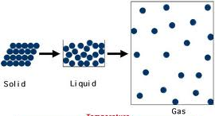
What happens to the motion of the particles?

What happens to the spacing of the particles?

What happens to the disorder of the particles?

What happens to the entropy of the particles?

2.7 Class Notes

Sample Questions:
Which list of the phases of H₂O is arranged in order of increasing entropy?
A) ice, steam, and liquid water
B) ice, liquid water, and steam
C) steam, liquid water, and ice
D) steam, ice, and liquid water

CIRCLE KEY WORDS!!!!

What is question asking us? _______________________________________________________________

__________________________________________________________________________________________

Things to think about when answering this:

a) Does entropy increase when temperature increases or decreases? __________________________________________________________________________________________

b) Which multiple choice answers can you eliminate and why?
__________________________________________________________________________________________

Why did you choose your answer? ________________________________________________________

__________________________________________________________________________________________

Which 10-milliliter sample of water has the greatest degree of disorder?
A) H₂O(g) at 120°C
B) H₂O() at 80°C
C) H₂O() at 20°C
D) H₂O(s) at 0°C

What is question asking us? _______________________________________________________________

__________________________________________________________________________________________

Why did you choose your answer? ________________________________________________________

2.7 Class Notes

Sample Questions:
Which change represents an increase of entropy?
a. | I₂(s) → I₂(g)
b. | I₂(g) → I₂()
c. | H₂O(g) → H₂O()
d. | H₂O() → H₂O(s)

CIRCLE KEY WORDS!!!!

What is question asking us? _______________________________________________________________

__________________________________________________________________________________________

Things to think about when answering this:

a) Does entropy increase when temperature increases or decreases? __________________________________________________________________________________________

b) Which multiple choice answers can you eliminate and why?
__________________________________________________________________________________________

Why did you choose your answer? ________________________________________________________

__________________________________________________________________________________________

Above 0ºC, ice changes spontaneously to water according to the following equation:
H₂O(s) + heat → H₂O().
The changes in H₂O(s) involve
a. | an absorption of heat and a decrease in entropy
b. | a release of heat and a decrease in entropy
c. | an absorption of heat and an increase in entropy
d. | a release of heat and an increase in entropy

What is question asking us? _______________________________________________________________

__________________________________________________________________________________________

Why did you choose your answer? ________________________________________________________

__________________________________________________________________________________________

2.7 Class Work

Question | Explanation of Answer
- Which phase change represents a decrease in entropy?  A) solid to liquid  B) gas to liquid  C) liquid to gas  D) solid to gas | KEY WORDS AND SYMBOLS:  EXPLANATION:  ________________________________________________  ________________________________________________  ________________________________________________  ________________________________________________  ________________________________________________
- As a system becomes less random, its entropy  A) decreases  B) increases  C) remains the same | KEY WORDS AND SYMBOLS:  EXPLANATION:  ________________________________________________  ________________________________________________  ________________________________________________  ________________________________________________
- Which change is accompanied by a decrease in entropy?  A) H₂O() → H₂O(s)  B) H₂O(s) → H₂O(g)  C) H₂O() → H₂O(g)  D) H₂O(s) → H₂O() | KEY WORDS AND SYMBOLS:  EXPLANATION:  ________________________________________________  ________________________________________________  ________________________________________________  ________________________________________________
- What occurs when a sample of CO₂(s) changes to CO₂(g)?  a. The gas has greater entropy and less order.  b. The gas has greater entropy and more order.  c. The gas has less entropy and less order.  d. The gas has less entropy and more order. | KEY WORDS AND SYMBOLS:  EXPLANATION:  ________________________________________________  ________________________________________________  ________________________________________________  ________________________________________________

2.7 Class Work

Question | Explanation of Answer
5. A 1 gram sample of a substance has the greatest entropy when it is in the  a. solid state  b. liquid state  c. crystalline state  d. gaseous state | KEY WORDS AND SYMBOLS:  EXPLANATION:  ________________________________________________  ________________________________________________  ________________________________________________  ________________________________________________
6. As the randomness of a system increases, the entropy of the system  a. decreases  b. increases  c. remains the same | KEY WORDS AND SYMBOLS:  EXPLANATION:  ________________________________________________  ________________________________________________  ________________________________________________
7. Which sample has the lowest entropy?  a. 1 mole of KNO₃()  b. 1 mole of KNO₃(s)  c. 1 mole of H₂O()  d. 1 mole of H₂O(g) | KEY WORDS AND SYMBOLS:  EXPLANATION:  ________________________________________________  ________________________________________________  ________________________________________________
Draw a particle diagram of a solid, liquid, and gas.
KEY
- Element A

SOLID | LIQUID | GAS

Aim:
2.8

Objective:

Real world connection:

Vocabulary:

Heat and Temperature
3-2-1 Protocol for Video
3 Things you learned from the video
1.

2.

3.

2 Questions You Have
1.

2.

1 Connection to Chemistry or Real Life
1.

2.8 Class Notes

HEAT vs. TEMPERATURE
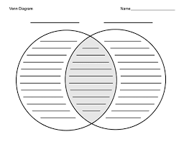

HEAT FLOW:
- energy is always transferred from __________________________________________ (more hot) to _______________________________ objects (less hot)
- this heat flow is measured through ________________________________________

2.8 Class Notes

QUESTIONS ON THE VIDEO:
1. How do molecules at warm temperatures differ from molecules at cool temperatures?
- At warm temperatures, molecules move around more
- At warm temperatures, molecules grow in size.
- At warm temperatures, molecules exchange electrons more easily
- At warm temperatures, molecules combine with each other more easily

2. What is the difference between heat and temperature?
- Temperature measures the motion of particles, and heat is the energy of that motion
- Temperature is measured by a thermometer, and heat is measured by a barometer
- Heat is measured in calories and temperature is measured in joules
- Heat is caused by the sun, and temperature is caused by conditions in the atmosphere
3. What happens to molecules when the temperature reaches absolute zero?
- They move so fast that they can’t be observed
- They begin to vibrate slowly
- All of their motion stops completely
- Heat is caused by the sun, and temperature is caused by conditions in the atmosphere
4. If you turn on a radiator, heat will diffuse throughout the room. What does this mean?
- The temperature will become unbearably hot
- The heated molecules will cool down
- The heat will be concentrated in one area of the room
- The heat will spread out

2.8 Class Notes

TERM | DEFINITION
Kinetic Energy

NOTE:
- ALL PARTICLES at the ________________________ TEMPERATURE have the ___________________ AVERAGE KINETIC ENERGY (type or amount of substance does not matter)
- As the kinetic energy __________________________, the temperature ________________________

EXAMPLE: Heating water on a stove to make tea
- When water is boiling, what do you see? ________________________________

- Why is that happening? ________________________________________________

- How does heat transfer? _______________________________________________

- When temperature increases, what is happening to the heat? What is happening to the kinetic energy?

EXAMPLE: Your tea is at 120ºC and your coffee is at 140ºC. Is the kinetic energy of the two drinks the same or different? Why?

2.8 Class Notes

SAMPLE QUESTION#1: CIRCLE THE KEY WORDS!!!!!!!

What occurs when a 35-gram aluminum cube at 100°C is placed in 90. grams of water at 25°C in an insulated cup?
A. Heat is transferred from the aluminum to the water, and the temperature of the water decreases.
B. Heat is transferred from the aluminum to the water, and the temperature of the water increases.
C. Heat is transferred from the water to the aluminum, and the temperature of the water decreases.
D. Heat is transferred from the water to the aluminum, and the temperature of the water increases.

What is question asking us? _______________________________________________________________

What are we given in the question that we NEED? _________________________________________

Any extra info in the question? If so, what is it? _____________________________________________

Things to think about when answering this:

a) Which has higher temperature? __________________________________________________________________________________________

b) Which has lower temperature?
__________________________________________________________________________________________

c) In general, does heat go from warmer to cooler or cooler to warmer?
__________________________________________________________________________________________

SAMPLE QUESTION#2: In which sample is the average kinetic energy of the particles greatest?
A) 10. mL of HCl(aq) at 25°C
B) 15 mL of HCl(aq) at 20.°C
C) 10. mL of H₂O() at 35°C
D) 15 mL of H₂O() at 30.°C

What is question asking us? _______________________________________________________________

What are we given in the question that we NEED? _________________________________________

Any extra info in the question? If so, what is it? _____________________________________________

Things to think about when answering this:

a) As the kinetic energy increases, what happens to the temperature? __________________________________________________________________________________________

b) Is kinetic energy affected by amount of substance?

2.8 Class Notes

Question | Explanation of Answer
Object A at 40ºC and object B at 80ºC are placed in contact with each other. Which statement describes the heat flow between the objects?  A) Heat flows from object A to object B.  B) Heat flows from object B to object A.  C) Heat flows in both directions between the objects.  D) No heat flow occurs between the objects | KEY WORDS AND SYMBOLS:  EXPLANATION:  ________________________________________________  ________________________________________________  ________________________________________________  ________________________________________________  ________________________________________________
The average kinetic energy of water molecules is greatest in which of these samples?  A) 10 g of water at 35°C  B) 10 g of water at 55°C  C) 100 g of water at 25°C  D) 100 g of water at 45°C | KEY WORDS AND SYMBOLS:  EXPLANATION:  ________________________________________________  ________________________________________________  ________________________________________________  ________________________________________________

Explain the relationship between heat, energy, and temperature. Be sure to use all of these terms in your paragraph response.

Aim:
2.9

Objective:

Real world connection:

Vocabulary:

3-2-1 Protocol for Video
3 Things you learned from the video
1.

2.

3.

2 Questions You Have
1.

2.

1 Connection to Chemistry or Real Life
1.

Temperature Scale | Unit Symbol
2.9 Class Notes

QUESTIONS ON THE VIDEO:
1. How does the air on a hot day compare with the air on a cold day?
- On a hot day, air molecules have more energy
- On a cold day, air molecules move faster
- On a hot day, the air contains more nitrogen
- On a cold day, air molecules don’t move at all

2. What happens inside a thermometer when the temperature goes up?
- The heat causes the liquid to become denser
- The heat causes liquid to expand
- The heat causes liquid to float
- The heat boils the liquid into a gas
3. In France, the air temperature is often 30 degree in summer time. In the northern U.S., it’s often 30 degrees in the winter. What is the most likely reasons for this?
- Winters in the northern U.S. are extremely warm
- France uses Celsius scale; the U.S. uses the Fahrenheit scale
- Summers in France are extremely cold
- France uses the Celsius scale; the U.S. uses the Kelvin scale.
4. How is the Kelvin scale different from the Fahrenheit and Celsius scales?
- The Kelvin scale is used in the U.S.; the Fahrenheit and Celsius scales are used in Europe
- The Kelvin scale measures a wider range of temperatures than the other scales
- The Kelvin scale has no negative numbers
- The Kelvin scale does not exist outside of science labs

2.9 Class Notes

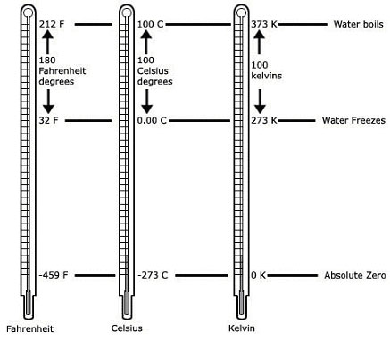
What do you notice about the temperature difference between freezing point and boiling point for Celsius and Kelvin?

This means…

Conversion Formula
ºC K

2.9 Class Notes

SAMPLE QUESTIONS:

What Kelvin temperature is equivalent to 35ºC?

What Celsius temperature is equivalent to 298K?

2.9 Class Work
Answer the following questions:
When the temperature of an object changes by 100ºC, the same temperature change in Kelvins would be  - 100 K  - 173 K  - 273 K  - 373 K | KEY WORDS AND SYMBOLS:  EXPLANATION:  ________________________________________________  ________________________________________________  ________________________________________________  ________________________________________________
When the temperature is at 95K, the same temperature in Celsius would be (SHOW WORK!!!!)
- -178 ºC
- 178 ºC
- -368 ºC
- 368 ºC

In a lab, you measure four liquids and got the following temperatures. List the following temperatures in order from least to greatest. SHOW WORK!
- 293 K
- 38ºC
- 42K
- 61ºC

Then list the temperatures above from the most kinetic energy to the least kinetic energy. Explain your reasoning.

2.9 Class Work
Convert the following Celsius temperatures to Kelvin temperatures:
A) 100ºC B) 0ºC

C) 785ºC D) -37ºC

Convert the following Kelvin temperatures to Celsius temperatures:
A) 273 K B) 0 K

C) 1200 K D) 100 K

