Aim:
2.10

Objective:

Real world connection:

Vocabulary:

Heating Curve
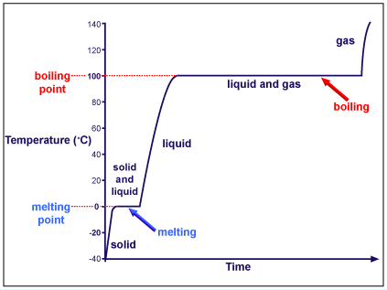
Think Ink:
Examine the heating curve to the right. Describe what happens to the temperature as the water on the right goes from -40°C to 140°C.

Separation of Mixtures
- _______________________ mixtures can be

Heating Curve

2.10 Class Notes
KEY TERMS FROM VIDEO
Heat of Fusion

Heat of Vaporization
Melting Point
Boiling Point
Sublimation

2 Questions You Have?

1 Connection to Chemistry/Real World
2.10 Class Notes

TYPES OF ENERGY
Kinetic Energy

Potential Energy

Relationship Between Energy & Temperature
- As temperature _________________________, the kinetic energy __________________________ because the motion of the particles ____________________________.
- As temperature _________________________, the potential energy ________________________ because heat is being added but the particles are not increasing in motion. This means the energy stored in the object is ____________________________.

Example of Heating Curve
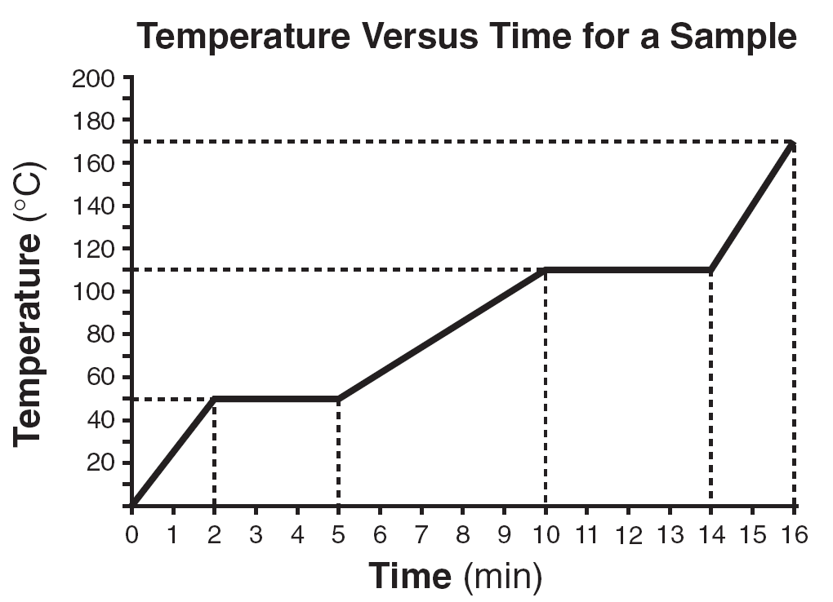

Parts of a heating curve
Line Segment | Phase of Matter Present/Process | Change in Temperature | Change in  Kinetic Energy of the particles | Change in Potential Energy of the Particles
A to B
Time range: ____________________
Temp. range: ___________________
B to C
Time range: ____________________
Temp. range: ___________________
C to D
Time range: ____________________
Temp. range: ___________________
D to E
Time range: ____________________
Temp. range: ___________________
E to F
Time range: ____________________
Temp. range: ___________________

2.10 Class Notes

Why is there no change in temperature during a phase change?
- During a phase change, the heat is used to break the _______________________________________________ rather than change the _____________________________________ of the particles
- Therefore, all phases present in the particles move with the same kinetic energy
SAMPLE QUESTION #1:
- A 100.0-gram sample of NaCl(s) (salt) has an initial temperature of 0°C. A chemist measures the temperature of the sample as it is heated. Heat is not added at a constant rate. The heating curve for the sample is shown below.
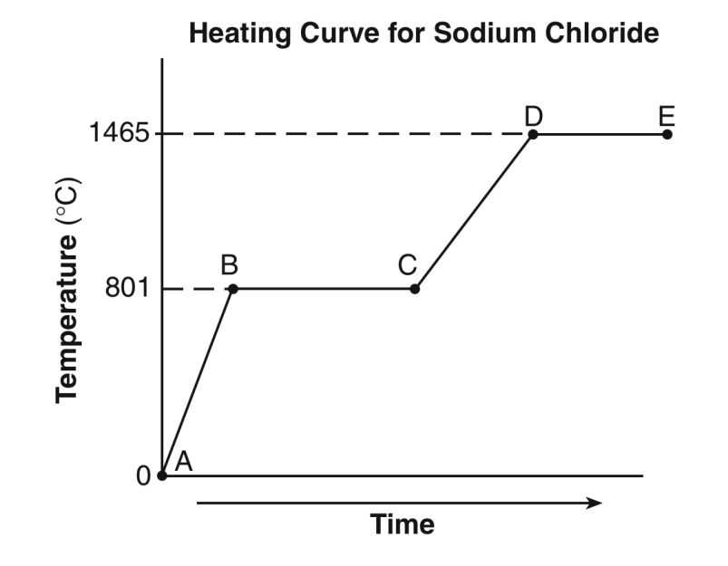
  - Determine the temperature range over which the entire NaCl sample is a liquid.

  - Identify one line segment on the curve where the average kinetic energy of the particles of the NaCl sample is changing.

  - Circle the portion of the graph where fusion is occurring.

  - Class Notes
SAMPLE QUESTIONS
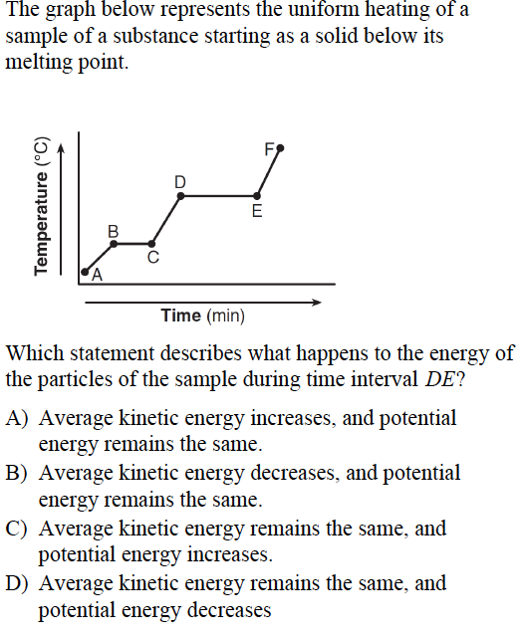
EXPLAIN YOUR ANSWER:
_________________________________________________________________________________________________________________________________________________________________________________________________________________________________________________________________________________________________________________________________________________________________________________________________________________________________________________________________________________________________________________________________________________________________________________________________________________________________________________________________________________________________________________________________________________________________

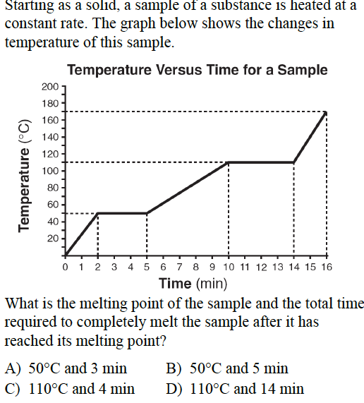
EXPLAIN YOUR ANSWER:
_______________________________________________________________________________________________________________________________________________________________________________________________________________________________________________________________________________________________________________________________________________________________________________________________________________________________________________________________________________________________________________________________________________________________________________________________________________________________________________________________________________________________________________________________________________________________________________________________________________________________________________________________________________________________________

2.10 Class Work

Directions: Answer all questions based on your knowledge of chemistry.
(ALWAYS LABEL CURVE FIRST)

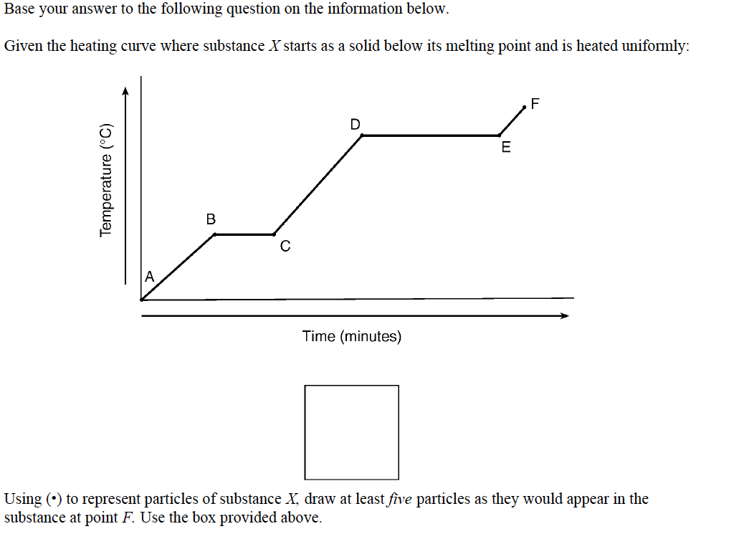

Describe what is happening to both the potential energy and the average kinetic energy of the molecules in the ammonia sample during time interval BC. Your response must include both potential energy and average kinetic energy.

2.10 Class Work

Directions: Answer all questions based on your knowledge of chemistry.
(ALWAYS LABEL CURVE FIRST)

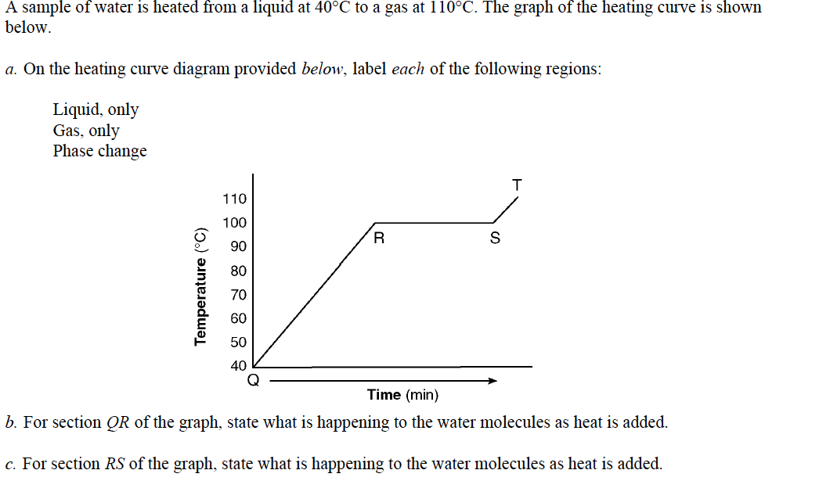
Hint for B & C: talk about how spread out they are, talk in terms of kinetic energy and potential energy.

Answer to b): ___________________________________________________________________________

_________________________________________________________________________________________

_________________________________________________________________________________________

Answer to c): ___________________________________________________________________________

_________________________________________________________________________________________

_________________________________________________________________________________________

2.10 Class Work

Directions: Answer all questions based on your knowledge of chemistry.

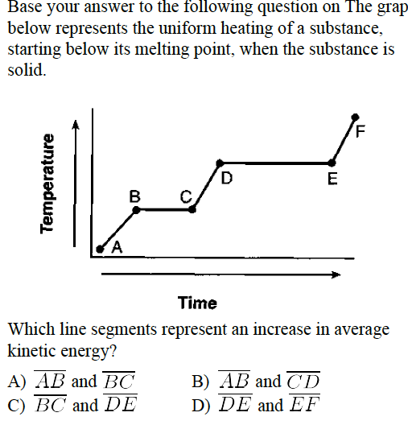

EXPLAIN YOUR ANSWER:
________________________________________________________________________________________________________________________________________________________________________________________________________________________________________________________________________________________________________________________________________________________________________________________________________________________________________________________________________________________________________________________________________________________________________________________________________________________________________________________________________________________________________________________________________________________________________________________________________________________________________________________________________________________________________________________________

2.10 Class Work

Directions: Answer all questions based on your knowledge of chemistry.

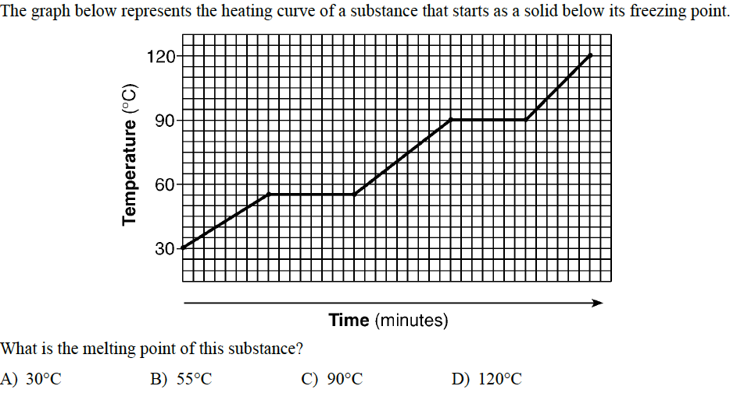

EXPLAIN YOUR ANSWER:
_________________________________________________________________________________________________________________________________________________________________________________________________________________________________________________________________________________________________________________________________________________________________________________________________________________________________________________________________________________________________________________________________________________________________________________________________________________________________________________________________________________________________________________________________________________________________________________________________________________________________________________________________________________________________________________________________

Aim:
2.11

Objective:

Real world connection:

Vocabulary:

Cooling Curve
Think Ink:
Examine the cooling curve to the right. Describe what happens to the temperature as the water on the right goes from 160°C to 10°C.

Cooling Curve

Parts of a cooling curve
Line Segment | Phase of Matter Present/Process | Change in Temperature | Change in  Kinetic Energy of the particles | Change in Potential Energy of the Particles
A to B
Time range: ____________________
Temp. range: ___________________
B to C
Time range: ____________________
Temp. range: ___________________
C to D
Time range: ____________________
Temp. range: ___________________
D to E
Time range: ____________________
Temp. range: ___________________
E to F
Time range: ____________________
Temp. range: ___________________

  - Class Notes

SAMPLE QUESTION
EXPLAIN YOUR ANSWER:
________________________________________________________________________________________________________________________________________________________________________________________________________________________________________________________________________________________________________________________________________________________________________________________________________________________________________________________________________________________________________________________________________________________________________________________________________________________________________________________________________________________________________________________________________________________________________________________________________________________

EXPLAIN YOUR ANSWER:
________________________________________________________________________________________________________________________________________________________________________________________________________________________________________________________________________________________________________________________________________________________________________________________________________________________________________________________________________________________________________________________________________________________________________________________________________________________________________________________________

2.11 Class Work

Directions: Answer all questions based on your knowledge of chemistry.
(ALWAYS LABEL CURVE FIRST)

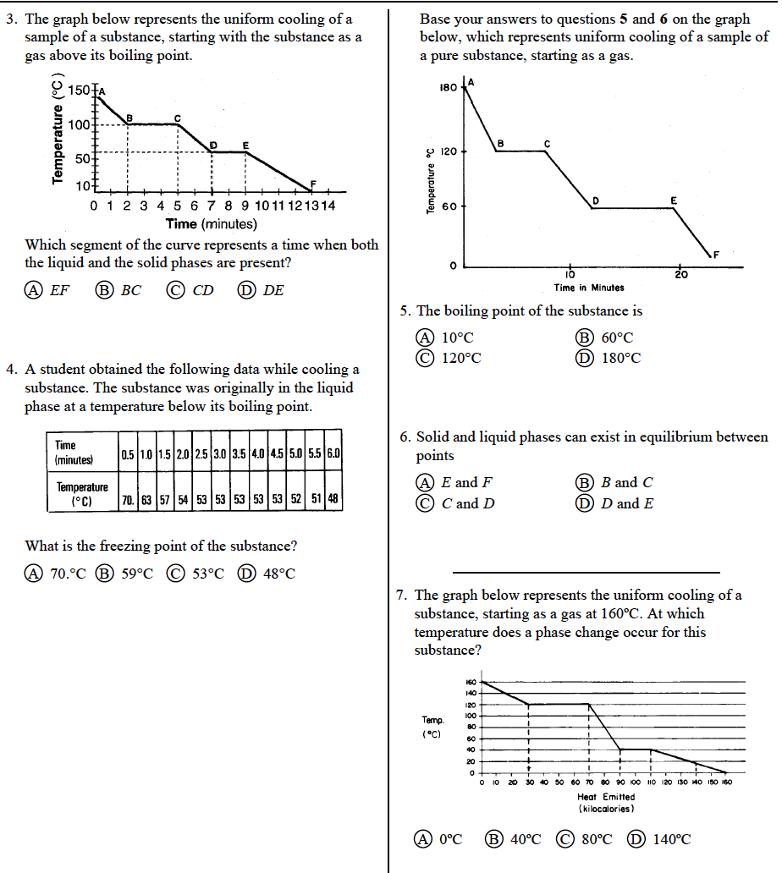

2.11 Class Work

Directions: Answer all questions based on your knowledge of chemistry.
(ALWAYS LABEL CURVE FIRST)

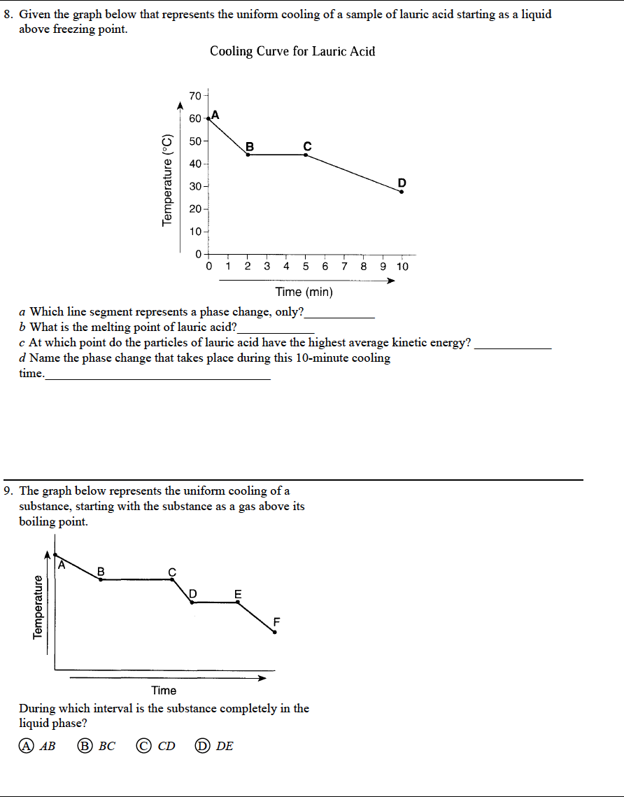

2.11 Class Work

Directions: Answer all questions based on your knowledge of chemistry.
(ALWAYS LABEL CURVE FIRST)

2.11 Class Work

Directions: Answer all questions based on your knowledge of chemistry.
(ALWAYS LABEL CURVE FIRST)

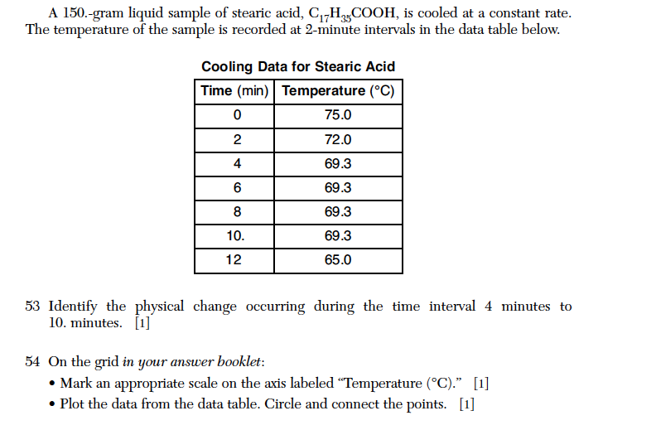

Aim:
2.12

Objective:

Real world connection:

Vocabulary:

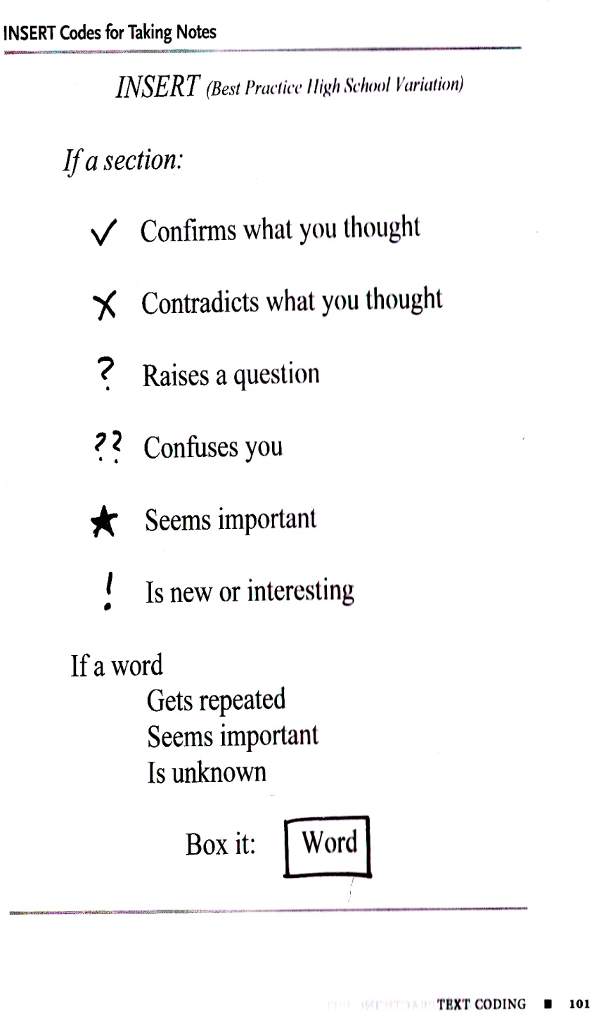
Heat of Phase Change
The heat absorbed by one gram of a solid substance as it melts to a liquid at a constant temperature is the heat of fusion, H_{f}. Each substance has its unique H_{f}—the one for water is found in Table B. The quantity of heat absorbed by a melting solid is exactly the same as the quantity of heat released when the liquid solidifies. The formula for using H_{f} to determine the heat (q) absorbed in Joules is found in Table T. The heat of fusion is used for any substance that is going from a solid to a liquid or from a liquid to solid.
The heat absorbed by one gram of a liquid substance as it vaporizes to a gas at a constant temperature is the heat of vaporization, H_{v}. Each substance has its unique H_{v}—the one for water is found in Table B. The quantity of heat absorbed by a vaporizing liquid is exactly the same as the quantity of heat released when the gas condenses. The formula for using H_{v} to determine the heat (q) absorbed in Joules is found in Table T. The heat of vaporization is used for any substance that is going from a liquid to a gas or from a gas to a liquid.
- Summarize the heat of fusion and heat of vaporization in your own words. Underline lines from the text where you learned this information.

2.12 Class Notes
- How does the amount of heat absorbed when a substance changes from a solid to a liquid compare to the amount released from a liquid to a solid change? (Hint: look at Table B)

- Using the reading and the ‘Heat’ equations on Table T, fill out the rest of the table below using the first row as an example.
Variable | Term | Units | What it means
q | heat | Joules | The total heat required for a phase change
 |  |  | The heat required to change one gram of substance from the solid to liquid phase.
 |  |  | The heat required to change one gram of substance from the liquid to the gas phase.
 |  |  | A measurement for how much matter we have.

From Table B
Heat of Fusion of Water
Heat of Vaporization of Water

Quick Check: Write down whether we would use H_{vap} or H_{fus} and explain why.
Scenario | Constant used? | Why?
Melting ice
Condensing water vapor into liquid water
Boiling water

2.12 Class Notes

Calculating Heat:
Phase Change | Heat of Fusion | Heat of Vaporization
Processes to use | Melting  _____________________--> __________________  Freezing  _____________________--> __________________ | Vaporization  _____________________--> __________________  Condensing  _____________________--> __________________
Equations
Constants

SAMPLE QUESTION #1: How many joules are required to melt 255g of ice at 0ºC?
Which formula to use? Why? ___________________________________________________________
_______________________________________________________________________________________
Use FLPS!

2.12 Class Notes

LET’S TRY! When 20.0 grams of a substance is completely melted at its melting point, 820. Joules are absorbed. What is the heat of fusion of this substance? Circle necessary numbers.
A) 41.0 J/g
B) 800. J/g
C) 840. J/g
D) 16,400 J/g

SAMPLE QUESTION #2: How many joules of energy are required to vaporize 423g of water at 100ºC and 1 atm? Circle necessary numbers.
Which formula to use? Why? ___________________________________________________________
_______________________________________________________________________________________
Use FLPS! And explain what you are doing step-by-step. One person show the work and the other explain.
Show Work Using FLPS (YOU) | Partner Explains the Process (PARTNER: _________________________)

2.12 Class Work

The heat of fusion of a compound is 126 Joules per gram. What is the total number of Joules of heat that must be absorbed by a 15.0-gram sample to change the compound from solid to liquid at its melting point? Circle necessary numbers.
A) 111 J
B) 141 J
C) 1,110 J
D) 1,890 J

When 20.0g of a substance are completed melted at its melting point, 3444J are absorbed. What is the heat of fusion of this substance? Circle necessary numbers.
(1) 41 J/G (2) 172 J/g (3) 16,400 J/g (4) 68,900 J/g

2.12 Class Work

At 1 atmosphere of pressure, 25.0 grams of a compound at its normal boiling point is converted to a gas by the addition of 34,400 Joules. What is the heat of vaporization for this compound, in Joules per gram? Circle necessary numbers.
A) 25.0 J/g
B) 1376 J/g
C) 2,260 J/g
D) 34,400 J/g

The boiling point of a liquid is the temperature at which the vapor pressure of the liquid is equal to the pressure on the surface of the liquid. The heat of vaporization of ethanol is 838 joules per gram. A sample of ethanol has a mass of 65.0 grams and is boiling at 1.00 atmosphere.

Calculate the minimum amount of heat required to completely vaporize this sample of ethanol. Your response must include both a correct numerical setup and the calculated result. Circle necessary numbers.

Aim:
2.13

Objective:

Real world connection:

Vocabulary:

CATALYST READING:
The amount of heat needed to increase the temperature of 1 g of an object exactly 1°C is known as the specific heat capacity, or the specific heat. Different substances with the same mass may have different heat capacities. On a sunny day, a 20-g puddle of water may be cool, while a nearby 20-g iron sewer cover may be too hot to touch. This situation illustrates how different specific heat capacities affect the temperature of objects. Assuming that both the water and the iron absorb the same amount of radiant energy from the sun, the temperature of the water changes less than the temperature of the iron because the specific heat of water is larger.
The amount of heat (q) absorbed or released in Joules during a temperature change is found in a formula on Table T. The specific heat of water is found on Table B.
- In your own words describe specific heat. Underline the sentence in the text that describes specific heat.

- Water is considered to have a high specific heat. How does this explain the situation where water heats up slower than iron?

- What is the formula for heat absorbed or released during temperature change:
Formula:
Term | Variable | Unit
Heat
Specific Heat Capacity
Mass
Change in temperature

2.13 Class Notes

Heat Capacity | - amount of heat needed to increase the temperature of an object by __________

Heat Capacity depends on:
- ______________________________________________

EXAMPLE: steel nail vs. steel rollercoaster

- ______________________________________________
EXAMPLE: gold vs. copper

Specific Heat Capacity | - amount of heat needed to increase the temperature of ___________ of an object by ____________

- For water, the specific heat capacity is ___________________ or ___________________

2.13 Class Notes

SAMPLE QUESTION #1: How many joules are absorbed when 50.0g of water are heated from 30.2ºC to 58.6ºC? USE FLIPS!

SAMPLE QUESTION #2: When 200 grams of water cools from 50°C to 25°C, the total amount of heat energy released by the water is
(1) 10,000 calories (2) 5,000 calories (3) 8 calories (4) 4 calories

2.13 Class Notes

YOU TRY! How much heat is required to heat 20 grams of water at 25ºC to 30ºC?
Use FLPS! And explain what you are doing step-by-step. One person shows the work and the other explain.
Show Work Using FLPS (YOU) | Partner Explains the Process (PARTNER: _________________________)

The temperature of a sample of water in the liquid phase is raised 30.0ºC by the addition of 3762J. What is the mass of the water? YOU TRY!
- 0.03g
- 0.30 g
- 30.0 g
- 300.0g

2.13 Class Work

Using joules, calculate how much heat 32.0g of water absorbs when it is heated from 25.0ºC to 80.0ºC. How many joules is this?

How many calories is this?

2.13 Class Work
How many calories of heat energy are released when 50 grams of water are cooled from 70ºC to 60ºC?
Show Work Using FLPS | Explain the Process
The temperature of a sample of water in the liquid phase is raised 45.0ºC by the addition of 695J. What is the mass of the water?
Show Work Using FLPS | Explain the Process

2.13 Class Work

How much heat, in joules, must be added to 178g of water to increase the temperature of the water by 5.0ºC?
- 890,000J
- 36,000 J
- 3,700J
- 93J

What is the total amount of heat absorbed by 100.0 grams of water when the temperature of the water is increased from 30.0°C to 45.0°C?

Aim:
2.14

Objective:

Real world connection:

Vocabulary:

Refresher: Calculating Heat

EQUATION | When do we use it? | Region(s) of the graph | Shape of graph
Heat of Fusion

Heat of Vaporization

Specific Heat

Heating Curve Flow Chart

Ask Yourself:
Is there a change in temperature?

Boiling/
vaporization
l g

Use formula:
q = mH_{v}
Use formula:
q = mH_{f}
Use formula:
q = mc$∆$t
Melting/ fusion
S l

No
Yes

Ask yourself:
Is it melting or is it boiling?

2.14 Class Notes

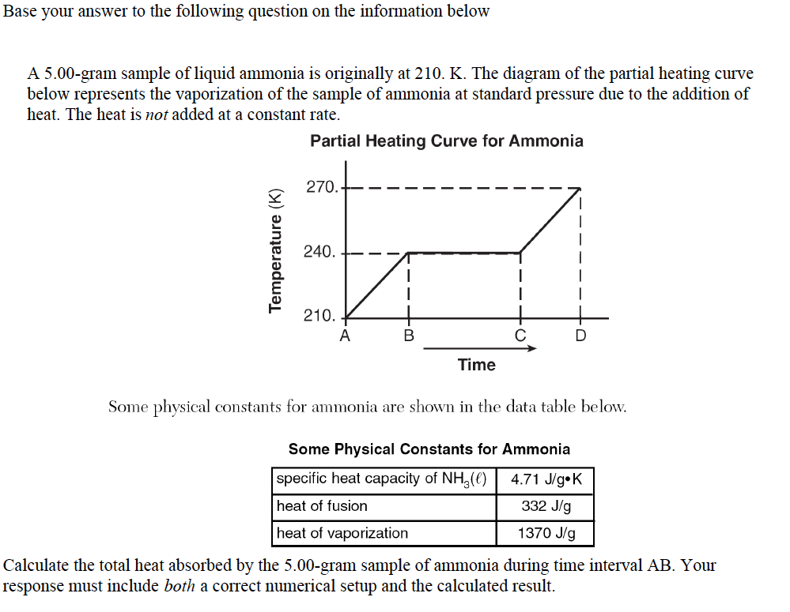
SAMPLE QUESTION

- A B represents what? __________________________________
- Is temperature increasing or staying the same? _________________________
- Which formula should we use out the three above? Why?
_______________________________________________________________________

2.14 Class Notes

SAMPLE QUESTION#2 continued:

B. Calculate the total heat absorbed by 5.00-gram sample of ammonia during interval BC.
Questions to consider:
- B C represents what? __________________________________
- Is temperature increasing or staying the same? _________________________
- Which formula should we use out the three above? Why?
_______________________________________________________________________

C. Calculate the total heat absorbed by 5.00-gram sample of ammonia during interval CD.
Questions to consider:
- C D represents what? __________________________________
- Is temperature increasing or staying the same? _________________________
- Which formula should we use out the three above? Why?
_______________________________________________________________________

2.14 Class Work

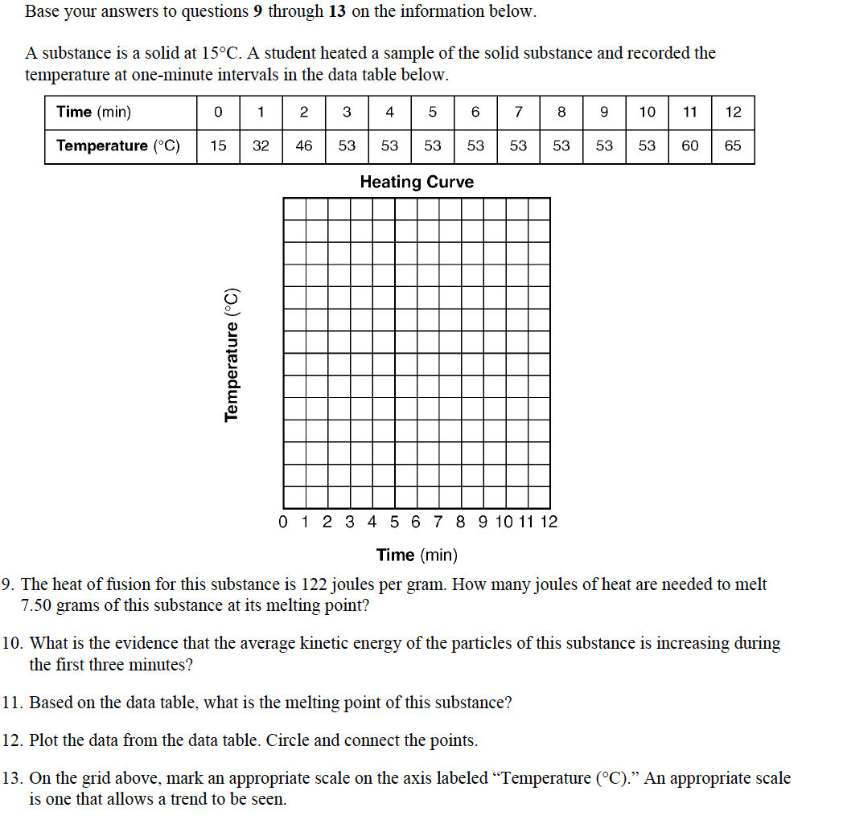

2.14 Class Work

Directions: Please answer the following questions. Decide which of the three heat formulas you will use in order to solve the problem before you begin
- The temperature of a sample of a substance is increased from 20.°C to 160.°C as the sample absorbs heat at a constant rate of 15 kilojoules per minute at standard pressure. The graph below represents the relationship between temperature and time as the sample is heated.
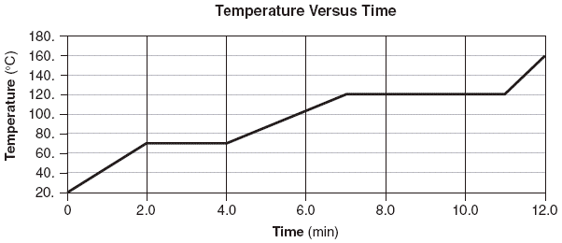
Determine the total amount of heat required to completely melt this sample at its melting point.

- The amount of energy needed to change a given mass of ice to water at constant temperature is called the heat of
- Condensation (3) Crystallization
- Fusion (4) Formation

2.14 Class Work

- How much heat is lost when 80 grams of water goes from 90ºC to 45ºC?

- How many joules of energy are released when 50 grams of water are cooled from 70ºC to 60ºC?

2.14 Class Work

- When 200 grams of water cools from 50ºC to 25ºC, what is the total amount of heat energy released by the water?

- The heat of fusion of a compound is 333.6 joules per gram. What is the total number of joules of heat that must be absorbed by a 15.0-gram sample to change the compound from solid to liquid at its melting point?

