Aim:
3.1

Objective:

Real world connection:

Vocabulary: Atom, atomic model, Dalton’s atomic theory, Plum-pudding model, nuclear model, Rutherford gold foil experiment, Bohr Model, wave mechanical model

Atoms
Atom
(neutral atom)
Atomic model

How are atoms like legoes?
THINK INK | PAIR SHARE

3.1 Class Work

Let’s watch a video
3-2-1 Protocol for BrainPop Video
3 Things you learned from the video
1.

2.

3.

2 Questions You Have
1.

2.

1 Connection to Chemistry or Real Life
1.

MODEL NAME | BILLIARD BALL | PLUM-PUDDING | RUTHERFORD | BOHR (PLANETARY) | WAVE-MECHANICAL (QUANTUM MECHANICAL/  ELECTRON CLOUD)
Name of Discover
IMPORTANT FINDINGS
WHAT WAS WRONG ABOUT THE PREVIOUS THEORY?
KEY EXPERIMENT
PICTURE |  | 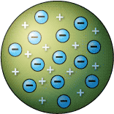 | 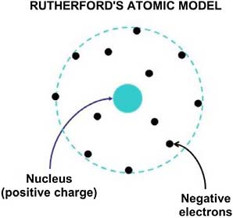 | 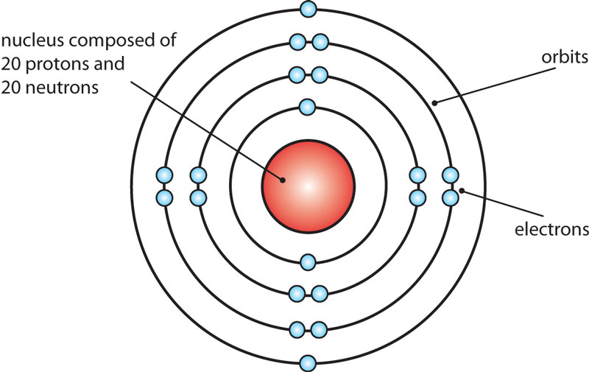 | 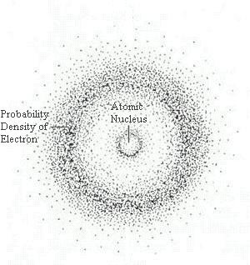
KEY WORDS | - Hard, empty sphere | - Evenly distributed charges | - Dense center  - Nucleus  - Mostly empty space | - Orbits  - Circular paths  - Shells | - Orbitals  - High probability regions of electrons

3.1 Class Notes
Use the following reading and the brainpop video to fill in the chart on previous page
Be sure to answer the questions below each section.

John Dalton 1766-1844
John Dalton was an English chemist. His ideas form the atomic theory of matter.
Here are his ideas:
1. All elements are composed (made up) of atoms. It is impossible to divide or destroy an atom. 2. All atoms of the same elements are alike. (One atom of oxygen is like another atom of oxygen.) 3. Atoms of different elements are different. (An atom of oxygen is different from an atom of hydrogen.) 4. Atoms of different elements combine to form a compound. These atoms have to be in definite whole number ratios. For example, water is a compound made up of 2 atoms of hydrogen and 1 atom of oxygen (a ratio of 2:1). Three atoms of hydrogen and 2 atoms of oxygen cannot combine to make water.

1. What is the name of his theory? ________________________________________________________
2. What are elements made of? __________________________________________________________
3. An atom of hydrogen and an atom of carbon are ______________________________________.
4. What are compounds made of ? _______________________________________________________
5. The ratio of atoms in HCl is a. 1:3 b. 2:1 c. 1:1
J.J. Thompson Late 1800s
J.J. Thompson was an English scientist. He discovered the electron when he was experimenting with gas discharge tubes. He noticed a movement in a tube. He called the movement cathode rays. The rays moved from the negative end of the tube to the positive end. He realized that the rays were rays were made of negatively charged particles – electrons.
1. What did J.J. Thompson discover? ______________________________________________________
2. What is the charge of an electron? _____________________________________________________
3. What are cathode rays made of? ______________________________________________________
4. Why do electrons move from the negative end of the tube to the positive end? __________________________________________________________________________________________
5. What was Thompson working with when he discovered the cathode rays? __________________________________________________________________________________________

3.1 Class Notes

Lord Ernest Rutherford 1871-1937
Ernest Rutherford conducted a famous experiment called the gold foil experiment. He took a thin sheet of gold foil. He used special equipment to shoot alpha particles (positively charged particles) at the gold foil. Most particles passed straight through the foil like the foil was not there. Some particles went straight back or were deflected (went in another direction) as if they had hit something. The experiment shows: atoms are made of a small positive nucleus; positive nucleus repels (pushes away) positive alpha particles; and atoms are mostly empty space.
1. What is the charge of an alpha particle? ____________________________________________
2. Why is Rutherford’s experiment called the gold foil experiment? ________________________
________________________________________________________________________________________
3. How did he know that atom was mostly empty space? ________________________________
_______________________________________________________________________________________
4. What happened to the alpha particles as they hit the gold foil? ________________________
________________________________________________________________________________________
5. How did he know that the nucleus was positively charged? ____________________________
________________________________________________________________________________________

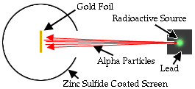
.
  - Class Notes
Niels Bohr Early 1900s
Niels Bohr was a Danish physicist. He proposed a model of the atom that is similar to the model of the solar system. The electrons go around the nucleus like planets orbit around the sun. All electrons have their energy levels – a certain distance from the nucleus. Each energy level can hold a certain number of electrons. Level 1 can hold 2 electrons, Level 2 – 8 electrons, Level 3 – 18 electrons, and Level 4 – 32 electrons. The energy of electrons goes up from Level 1 to other levels. When electrons release (lose) energy they go down a level. When electrons absorb (gain) energy, they go to a higher level.
1. Why could Bohr’s model be called a planetary model of the atom? _____________________
__________________________________________________________________________________________
2. How do electrons in the same atom differ? _____________________________________________
__________________________________________________________________________________________
3. How many electrons can the fourth energy level hold? __________________________________
4. Would an electron have to absorb or release energy to jump from the second energy level to the third energy level? ____________________________________________________________
5. For an electron to fall from the third energy level to the second energy level, it must ________________________ energy.

Quantum Mechanical Model
Many scientists contributed to the development of the quantum mechanical model of the atom: Bohr, Planck, DeBroglie, Heisenberg, Schrodinger, Pauli. Louis de Broglie in 1923 proposed that moving particles like electrons have some wave properties. Erwin Schrodinger develops mathematical equations to describe the motion of electrons in atoms, which leads to the quantum mechanical mode. This model states that the electron cloud is a visual model of the probable locations of electrons in an atom. Since it is impossible to say exactly where an electron is at any exact point, the cloud around the nucleus gives us an idea of where they’re located. So, the densest part of the cloud is where most of the electrons are located, while the lighter regions have less electrons. We call these areas orbitals.
- According to this theory, electrons are both __________________ and _________________.
- What is an electron cloud? ________________________________________________________.
- What are orbitals? _________________________________________________________________.
- Where are we most likely to find electrons? __________________________________________
- Where are we least likely? __________________________________________________________
  - Class Notes (Sample Questions)

Sample Question | Explanation of Answer
- Which sequence represents a correct order of historical developments leading to the modern model of the atom  - the atom is a hard sphere most of the atom is empty space electrons exist in orbitals outside the nucleus  - the atom is a hard sphere electrons exist in orbitals outside the nucleus most of the atom is empty space  - most of the atom is empty space electrons exist in orbitals outside the nucleus most of the atom is empty space  - most of the atom is empty space the atom is a hard sphere electrons exist in orbitals outside the nucleus | KEY WORDS AND SYMBOLS:  EXPLANATION:  ________________________________________________  ________________________________________________  ________________________________________________  ________________________________________________  ________________________________________________
- Which statement correctly describes the charge of the nucleus and the charge of the electron cloud of an atom?  - The nucleus is positive and the electron cloud is positive.  - The nucleus is positive and the electron cloud is negative.  - The nucleus is negative and the electron cloud is positive.  - The nucleus is negative and the electron cloud is negative. | KEY WORDS AND SYMBOLS:  EXPLANATION:  ________________________________________________  ________________________________________________  ________________________________________________  ________________________________________________  ________________________________________________
- According to the wave-mechanical model of the atom, electrons in an atom  - are mostly likely found in the excited state  - have a positive charge  - are located in orbitals outside the nucleus  - travel in defined circles | KEY WORDS AND SYMBOLS:  EXPLANATION:  ________________________________________________  ________________________________________________  ________________________________________________  ________________________________________________

3.1 Class Work

Directions: Answer all questions based on your knowledge of chemistry.
Part I: Match these key words with the appropriate model of the atom.

Key Words | Model of the Atom
Hard sphere
Defined circular paths
Orbital
Dense positively charged nucleus
Mostly empty space
Specific shell of electrons

1. The first subatomic particle discovered was the
(1) proton (3) electron
(2) neutron (4) photon

2. Which group of atomic models is listed in historical order from earliest to the most recent?
- Hard-sphere model, wave-mechanical model, electron-shell model
- Hard-sphere model, electron-shell model, wave mechanical model
- Electron-shell model, wave-mechanical model, hard-sphere model
- Electron-shell model, hard-sphere model, wave-mechanical mode

3. In the wave-mechanical model of the atom, orbitals are regions of the most probable locations of
(1) protons (3) neutrons
(2) positrons (4) electrons

4. Which phrase describes an atom?
(1) a positively charged electron cloud surrounding a positively charged nucleus
(2) a positively charged electron cloud surrounding a negatively charged nucleus
(3) a negatively charged electron cloud surrounding a positively charged nucleus
(4) a negatively charged electron cloud surrounding a negatively charged nucleus

Aim:
3.2

Objective:

Real world connection:

Vocabulary: Rutherford’s gold foil experiment, alpha particles, deflected

CATALYST ACTIVITY
Before Ernst Rutherford performed the gold foil experiment, the plum-pudding model was the accepted model of the atom. According to the plum-pudding model, atoms were made up of positive and negative charges that were spread around in a cloud-like sphere.
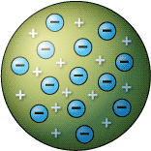
Let’s say that the atoms on the left represent gold atoms in a sheet of gold foil. These atoms are the plum-pudding model which represents the atom as a cloud of positive and negative charges. If we were to fire a stream of positive charges, predict the where the positive charges would go.

TASK:
- Draw arrows to show direction of positive charges if shot through the gold foil from left to right.

DEFEND YOUR ANSWER and explain why you decided to draw the arrows the way you did.

_________________________________________________
________________________________________________

3.2 Class Notes

THE GOLD FOIL EXPERIMENT
 | PICTURE | EXPLANATION
Prediction if the Plum-Pudding model of the atom were true. | 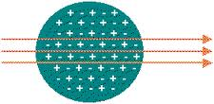 | __________________________________________________________  _____________________________________________________  _____________________________________________________  _____________________________________________________  ____________________________________________________  ________________________________________________________  _____________________________________________________
What actually happened | 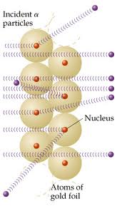 | __________________________________________________________  _____________________________________________________  _____________________________________________________  _____________________________________________________  ____________________________________________________  ________________________________________________________  _____________________________________________________

What were the two conclusions of the gold-foil experiment?
 | Conclusion | Experimental Evidence
1
2

3.2 Class Work

Directions: Answer all questions based on your knowledge of chemistry.
- The gold-foil experiment led scientists to conclude that an atom’s
- Positive charge is evenly spread throughout its volume
- Negative charge is mainly concentrated in its nucleus
- Mass is evenly spread throughout its volume
- Volume is mainly empty space

- In Rutherford’s gold foil experiments, some alpha particles were deflected from their original paths but most passed with no deflection. Which statement about gold atoms is supported by these experimental observations?
- Gold atoms consist mostly of empty space.
- Gold atoms are similar to alpha particles.
- Alpha particles and gold nuclei have opposite charges
- Alpha particles are more dense than gold atoms.

- The gold foil experiment led to the conclusion that each atom in the foil was composed mostly of empty space because most alpha particles directed at the foil
- Passed through the foil
- Remained trapped in the foil
- Were deflected by the nuclei in gold atoms
- Were deflected by the electrons in gold atoms

- John Dalton was an English scientist who proposed that atoms were hard, indivisible spheres. In the modern model, the atom has a different internal structure.

- Identify one experiment that led scientists to develop the modern model of the atom?
________________________________________________________________________________________________________________________________________________________________________________________________________________________________________________
- Describe this experiment.

________________________________________________________________________________________________________________________________________________________________________________________________________________________________________________________________________________________________________________________________________________________________________
- State one conclusion about the internal structure of the atom, based on this experiment.
________________________________________________________________________________________________________________________________________________________________________________________________________________________________________________________________________________________________________________________________________________________________________

3.2 Class Work

- One model of the atom states that atoms are tiny particles composed of a uniform mixture of positive and negative charges. Scientists conducted an experiment where alpha particles were aimed at a thin layer of gold atoms.

Most of the alpha particles passed directly through the gold atoms. A few alpha particles were deflected from their straight-line paths. An illustration of the experiment is shown below.

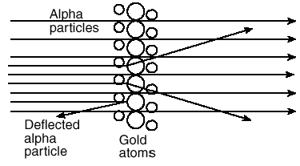

- Most of the alpha particles passed directly through the gold atoms undisturbed. What evidence does this suggest about the structure of gold atoms?
________________________________________________________________________________________________________________________________________________________________________________________________________________________________________________________________________________________________________________________________________________________________________________________________________________________________________________________________________________________________

- A few of the alpha particles were deflected. What does this evidence suggest about the structure of the gold atoms?
________________________________________________________________________________________________________________________________________________________________________________________________________________________________________________________________________________________________________________________________________________________________________________________________________________________________________________________________________________________________

- How should the original model be revised based on the results of this experiment?
________________________________________________________________________________________________________________________________________________________________________________________________________________________________________________________________________________________________________________________________________________________________________________________________________________________________________________________________________________________________

Aim:
3.3

Objective:

Real world connection:

Vocabulary: Atom, subatomic particles, protons, neutrons, electrons, nucleon, nuclide

Why is a battery labeled with a + and -?
How does magnetism work?
THINK INK | PAIR SHARE

3.3 Class Work

Let’s watch a video
3-2-1 Protocol for BrainPop Video
3 Things you learned from the video
1.

2.

3.

2 Questions You Have
1.

2.

1 Connection to Chemistry or Real Life
1.

3.3 Class Notes

Subatomic Particles
Subatomic particles

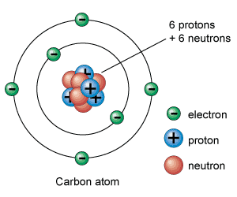
The 3 subatomic particles of the atom are:
- _______________________________
- _______________________________
- _______________________________

Subatomic Particles: Use article to fill out this chart
PARTICLE | Symbol | SIZE (in amu) | LOCATION:  Where in the Atom? | CHARGE: Positive, negative, neutral?
Proton
Neutron
Electron

3.3 Class Notes

Charge of Atom
- How many protons does this atom have? _______________

- How many electrons does this atom have? ______________

- How many neutrons does this atom have? ______________

- # of nucleons: ______________________

- Positive charge: __________ Negative charge: __________

- Overall charge: ________________________________

What is an atom’s overall charge? Why is that?
THINK INK | PAIR SHARE

3.3 Class Notes (Sample Questions)

SAMPLE QUESTION #1:
Which total mass is the smallest?
(1) the mass of 2 electrons
(2) the mass of 2 neutrons
(3) the mass of 1 electron plus the mass of 1 proton
(4) the mass of 1 neutron plus the mass of 1 electron

Let’s solve each multiple choice answer:

- ____________________________________
- ____________________________________
- ____________________________________
- ____________________________________

SAMPLE QUESTION #2: Base your answers on the information below:

In the modern model of the atom, each atom is composed of three major subatomic (or fundamental) particles.

- Name the subatomic particles contained in the nucleus of the atom

- State the charge associated with each type of subatomic particle contained in the nucleus of the atom.

- What is the net charge of the nucleus?

3.3 Class Work

Answer the following questions

1. Which statement best describes electrons?
(1) They are positive subatomic particles and are found in the nucleus.
(2) They are positive subatomic particles and are found surrounding the nucleus.
(3) They are negative subatomic particles and are found in the nucleus.
(4) They are negative subatomic particles and are found surrounding the nucleus.

2. Which particles are found in the nucleus of an atom?
(1) electrons, only
(2) neutrons, only
(3) protons and electrons
(4) protons and neutrons

3. Which statement is true about the charges assigned to an electron and a proton?
(1) Both an electron and a proton are positive.
(2) An electron is negative and a proton is positive.
(3) An electron is positive and a proton is negative.
(4) Both an electron and a proton are negative.

4. Which statement is true about a proton and an electron?
(1) They have the same masses and the same charges.
(2) They have the same masses and different charges.
(3) They have different masses and the same charges.
(4) They have different masses and different charges.

5. Which subatomic particle will be attracted by a positively charged object?
- proton
- neutron
- electron
- positron

6. Which two particles have approximately the same mass?
(1) proton and neutron
(2) proton and electron
(3) neutron and electron
(4) neutron and positron

3.3 Class Work
Answer the following questions
15 p
16 n
10 p
10 n

10 n

16 n

How many Protons? _________ How many Protons? _________
How many Electrons? _______ How many Electrons? _______
How many Neutrons? _______ How many Neutrons? _______
# of nucleons: __________ # of nucleons: __________
Positive charge: ___________ Positive charge: ___________
Negative charge: __________ Negative charge: __________
Overall charge: ___________ Overall charge: ___________

Fill in the blank with the following words:
Outside neutrons same cancel out protons atoms negative electrons Nucleus smaller no positive
- All matter is made of tiny particles called _______________________.
- The center of an atom is called the __________________________.
- A nucleus is made up of ______________________ and __________________________.
- Electrons are found ___________________________ the nucleus.
- Electrons are ___________________________ than protons and neutrons.
- The main parts of an atom are _____________________, ____________________, and _______________.
- Since protons have a ___________________ charge, and neutrons have _______________ charge, the nucleus will have a ________________________ charge.
- Electrons have a ____________________ charge.
- An atom has the ________________ number of protons and neutrons.
- The plus and minus charges of an atom _____________________________ each other.

Aim:
3.4

Objective:

Real world connection:

Vocabulary: Atomic number, atomic mass, mass number

Activity: THINK INK…PAIR SHARE
What do you think gives an element its identity?

THINK INK | PAIR SHARE

3.4 Class Notes
Identifying Elements
- Every element has a different ________________________________________________

Atomic Number
(Symbol: Z)

Atomic Number of a NEUTRAL atom tells you:
- number of ____________________________
- number of ____________________________

NOTE
- No two elements have the same ___________________________= no two elements have the same number of _________________________.
- However, the number of ___________________________ and _______________________ in an atom of the same element can be different!

Mass Number
Mass Number

Formula:

3.4 Class Notes (Sample Questions)

Example #1: (Fill in atomic mass, symbol & atomic # of carbon)

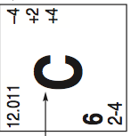
Name of element: _________________________
Atomic #: _________________________________
# of protons: ______________________________
# of electrons: ____________________________
Atomic mass: _____________________________
Mass #: __________________________________
# of neutrons: ____________________________

Example #2:
For this element, please draw how it looks on periodic table

Name of element: _________________________ Atomic #: _________________________________
# of protons: ______________________________ # of electrons: ____________________________
Atomic mass: _____________________________ Mass #: __________________________________
# of neutrons: ____________________________

3.4 Class Notes (Sample Questions)

Example #3:
How many protons and electrons are present in an argon atom?

What is the name of the element that has atoms that contain 17 protons?

Example #4:
What is the total number of neutrons in an atom of an element that has a mass number of 19 and an atomic number of 9? (1) 9 (2) 19 (3) 10 (4) 28

A neutral atom contains 12 neutrons and 11 electrons. The number of protons in this atom is (1) 1 (2) 11 (3) 12 (4) 23 What element is this? ________________________

3.4 Class Work

Fill in the missing items in the table provided below.
Name of Element | Symbol of Element | Atomic # | Mass # | # Protons | # Electrons | # Neutrons
 | Na
 |  | 17
Potassium
 | P
 |  |  |  | 53
Silver
 |  | 36
 | W
 |  | 29
 |  |  |  | 49

Practice Problems
- How many protons and electrons are present in a vanadium atom?

- How many protons, electrons, and neutrons are present in a platinum atom?

- What is the name of the element that has atoms that contain 5 protons?

- What is the name of the element that has atoms that contains 82 protons?

- What is the atomic number of the element that has 74 protons? What is the name of that element?

3.4 Class Work

The number of neutrons in the nucleus of an atom can be determined by
(1) adding the atomic number to the mass number
(2) subtracting the atomic number from the mass number
(3) adding the mass number to the atomic mass
(4) subtracting the mass number from the atomic number

In which list are the elements arranged in order of increasing atomic mass?
(1) Cl, K, Ar
(2) Fe, Co, Ni
(3) Te, I, Xe
(4) Ne, F, Na

The atomic number of an atom is always equal to the number of its
(1) protons, only
(2) neutrons, only
(3) protons plus neutrons
(4) protons plus electrons

What is the total number of electrons found in an atom of sulfur?
- 6
- 8
- 16
- 32

What is the total number of neutrons in the nucleus of a neutral atom that has 19 electrons and a mass number of 39?
(1) 19
(2) 20
(3) 39
(4) 58

Name the element that has the following numbers of particles:
- 26 electrons, 29 neutrons, 26 protons ______________________
- 53 protons, 74 neutrons ___________________________________
- 2 electrons in a neutral atom ______________________________
- 20 protons ________________________________________________

Aim:
3.5

Objective:

Real world connection:

Vocabulary: Isotope, hyphen notation, nuclear notation

Activity: THINK INK…PAIR SHARE
How are twins similar to each other? How are they different from each other?

THINK INK | PAIR SHARE

3.5 Class Work

Let’s watch a video
3-2-1 Protocol for BrainPop Video
3 Things you learned from the video
1.

2.

3.

2 Questions You Have
1.

2.

1 Connection to Chemistry or Real Life
1.

3.5 Class Notes
How can two atoms of the same element have different number of neutrons?

THINK INK | PAIR SHARE

Term | Definition
Isotope
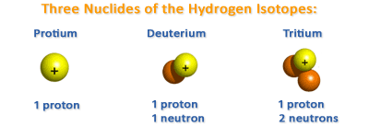

Similarities | Differences

3.5 Class Notes

Notations for Isotopes
- There are different ways to represent isotopes

- Hyphen Notation
Carbon-12
C-12
- Nuclear Notation

Superscript: _____________________
Subscript: ____________________
¹²C

¹²₆C

3.5 Class Notes

EXAMPLE: Isotopes of Oxygen
Hyphen Notation 1
Hyphen Notation 2
Nuclear Notation 1
Nuclear Notation 2
Element | Oxygen | Oxygen | Oxygen
Mass Number | 16 | 17 | 18
# of Protons
# of Neutrons
# of Electrons

Steps to figuring out the number of neutrons in an isotope:
- Determine the number mass number and the atomic number of the isotope.

Example: Carbon-13
What is the mass number? ______
What is the atomic number? _______

- Subtract the number mass number from the atomic number to get the number of neutrons.

Example: Carbon-13
What is the number of neutrons? _______

3.5 Class Notes (Sample Questions)
YOU TRY!: Isotopes of Potassium
Hyphen Notation 1 | Potassium-39 | Potassium-40 | Potassium-41
Hyphen Notation 2
Nuclear Notation 1
Nuclear Notation 2
Element
Mass Number
# of Protons
# of Neutrons
# of Electrons

Sample Question | Explanation of Answer
1. The nucleus of an atom of K-42 contains  (1) 19 protons and 23 neutrons  (2) 19 protons and 42 neutrons  (3) 20 protons and 19 neutrons  (4) 23 protons and 19 neutrons | KEY WORDS AND SYMBOLS:  EXPLANATION:
2. The nucleus of an atom of ⁴²K contains  (1) 19 protons and 23 neutrons  (2) 19 protons and 42 neutrons  (3) 20 protons and 19 neutrons  (4) 23 protons and 19 neutrons | KEY WORDS AND SYMBOLS:  EXPLANATION:

3.5 Class Work

Describe, in terms of subatomic particles found in the nucleus, one difference between the nuclei of Chlorine-35 atoms and the nuclei of Chlorine-37 atoms. The response must include both isotopes.

For each of the following isotopes, write the number of protons, neutrons, and electrons as well as the other notation specified.

 | Nitrogen-15 | Nitrogen-20
# of protons
# of electrons
# of neutrons
Other hyphenated notation

 | S-23 | S-25
# of protons
# of electrons
# of neutrons
Other hyphenated notation

 | ²³⁸ ₉₂ U | ²³⁵ ₉₂ U
# of protons
# of electrons
# of neutrons
Element
Other nuclear notation

 | ¹⁴N | ¹²N
# of protons
# of electrons
# of neutrons
Element
Other nuclear notation

3.5 Class Work

Atoms of the same element that have different numbers of neutrons are classified as
(1) charged atoms
(2) charged nuclei
(3) isomers
(4) isotopes

All the isotopes of a given atom have
(1) the same mass number and the same atomic number
(2) different mass numbers but the same atomic number
(3) the same mass number but different atomic numbers
(4) different mass numbers and different atomic numbers

What is the total number of protons in the nucleus of an atom of potassium-42?
- 15 (2) 19 (3) 39 (4) 42

An atom of carbon-12 and an atom of carbon-14 differ in
(1) atomic number
(2) mass number
(3) nuclear charge
(4) number of electrons

The nucleus of an atom of cobalt-58 contains
(1) 27 protons and 31 neutrons
(2) 27 protons and 32 neutrons
(3) 59 protons and 60 neutrons
(4) 60 protons and 60 neutrons

Which statement concerning elements is true?
(1) Different elements must have different numbers of isotopes.
(2) Different elements must have different numbers of neutrons.
(3) All atoms of a given element must have the same mass number.
(4) All atoms of a given element must have the same atomic number.

3.5 Class Work

Describe, in terms of subatomic particles found in the nucleus, one difference between the nuclei of carbon- 12 atoms and the nuclei of carbon-13 atoms. The response must include both isotopes.

Atoms of ¹⁶O, ¹⁷O, and ¹⁸O have the same number of
- neutrons but a different number of protons
- protons but a different number of neutrons
- protons but a different number of electrons
- electrons but a different number of protons

The total number of protons and neutrons in the nuclide ³⁵₁₇ Cl is
- 52
- 35
- 18
- 17

The nuclides ¹⁴₆ C and ¹⁴₇ N are similar in that they both have the same
- mass number
- atomic number
- number of neutrons
- nuclear charge

Which symbols represent atoms that are isotopes of each other?
- ¹⁴C and ¹⁴ N
- ¹⁶O and ¹⁸ O
- ¹³¹ I and ¹³¹ I
- ²²²Rn and ²²² Ra

Explain the answer you chose for the question above:

