|  |
| --- |
| **Aim:**  **3.6** |
| **Objective:** |
| **Real world connection:** |
| **Vocabulary:** average atomic mass, percent abundance |

**Average Atomic Mass**

Below are the three naturally occurring isotopes of sulfur. Three key numbers are highlighted.

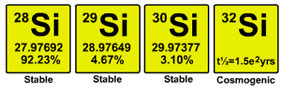

Mass number of isotope (actual)

Mass number of isotope (rounded)

Percent Natural Abundance of that isotope

* The actual atomic mass number for Silicon on the periodic table is: 28.0855. This number is considered the **average atomic mass**.

|  |  |
| --- | --- |
| **Average Atomic Mass** |  |
| **Percent Abundance** |  |

|  |
| --- |
| **3.6 Class Notes** |

**Sample Question #1**

* Let’s look at an example using silicon isotopes:

The accepted values for the atomic mass and percent natural abundance of each naturally occurring isotope of silicon are given in the data table below:

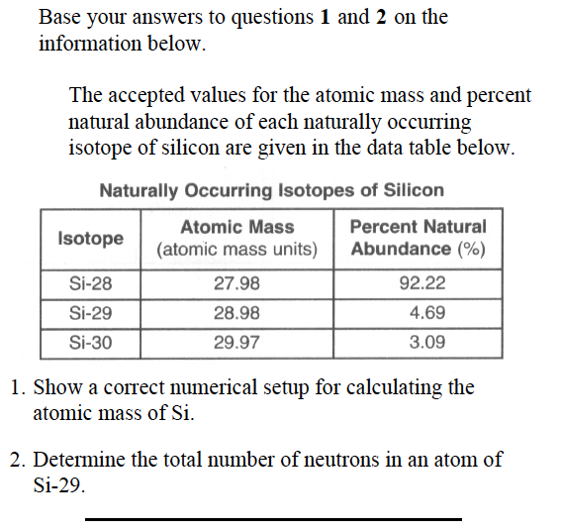

1. Show a correct numerical setup for calculating the atomic mass of Si
2. Determine the total number of neutrons in an atom of Si-29. ______________________________

* To find the average atomic mass, there are 6 simple steps:

|  |
| --- |
| Step 1: List the **Isotopes** |
| Step 2: Write **Mass Number** (actual if given) |
| Step 3: Write **Percent Natural Abundance** of isotope |
| Step 4: Determine **Relative Natural Abundance**  Formula: **Percent Natural Abundance / 100** |
| Step 5: Determine **Relative Mass**  Formula: **Relative Natural Abundance x Mass Number** |
| Step 6: Find **Average Atomic Mass = Atomic Mass Number**  Formula: **ADD EACH RELATIVE MASS** |

|  |
| --- |
| **3.6 Class Notes** |

**Sample Question #2**



* Predict whether you think the answer will be closer to 63 or 65. Explain why.
* The atomic mass of copper is 63.546 amu. Which of copper’s two isotopes is more abundant: copper-63 or copper-65? Explain your reasoning.

**Calculate the atomic mass of copper:**

|  |
| --- |
| **3.6 Class Work** |

This one has four different isotopes.

* Calculate the atomic mass. What whole number do you predict it to be close to?



* Now calculate the atomic mass of this one:

|  |  |  |
| --- | --- | --- |
|  | Mass Number | Natural Abundance |
| $${}_{7}^{14}N$$ | 14.00307 | 99.63% |
| $${}_{7}^{15}N$$ | 15.0001 | 0.37% |

|  |
| --- |
| **3.6 Class Work** |

Naturally occurring boron is composed of two isotopes. The percent abundance and the mass of each isotope are listed below.

• 19.9% of the boron atoms have a mass of 10.013 atomic mass units.

• 80.1% of the boron atoms have a mass of 11.009 atomic mass units.

**Calculate the atomic mass of boron. Your response must include both a correct numerical setup and the calculated result (and correct units!!!!!)**

Naturally occurring elemental carbon is a mixture of isotopes. The percent composition of the two most abundant isotopes is listed below.

• 98.93% of the carbon atoms have a mass of 12.00 atomic mass units.

• 1.07% of the carbon atoms have a mass of 13.00 atomic mass units.

A. Describe, in terms of subatomic particles found in the nucleus, one difference between the nuclei of carbon-12 atoms and the nuclei of carbon-13 atoms. The response must include both isotopes.

B. In the space provided in your answer booklet, show a correct numerical setup for calculating the average atomic mass of carbon.

|  |
| --- |
| **3.6 Class Work** |

Base your answers to the questions below on the data table below, which show three isotopes of neon.

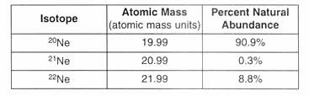

In terms of atomic particles, state one difference between these three isotopes of neon.

Based on the atomic masses and the natural abundances shown in the data table show a correct numerical setup for calculating the average atomic mass of neon.

Based on natural abundances, the average atomic mass of neon is closest to which whole number? ________________________

|  |
| --- |
| **3.6 Class Work** |

**Which statement best explains why most atomic masses on the Periodic Table are decimals?**

A) Atomic masses are determined relative to an H–1 standard.

B) Atomic masses are determined relative to an O–16 standard.

C) Atomic masses are a weighted average of the naturally occurring isotopes.

D) Atomic masses are an estimated average of the artificially produced isotopes.

**What information is necessary to determine the atomic mass of the element chlorine?**

A) the atomic mass of each artificially produced isotope of chlorine, only

B) the relative abundance of each naturally occurring isotope of chlorine, only

C) the atomic mass and the relative abundance of each naturally occurring isotope of chlorine

D) the atomic mass and the relative abundance of each naturally occurring and artificially produced isotope of chlorine

**Which value of an element is calculated using both the mass and the relative abundance of each of the naturally occurring isotopes of this element?**

A) atomic number B) atomic mass

C) half-life D) molar volume

**A 100.00-gram sample of naturally occurring boron contains 19.78 grams of boron-10 (atomic mass = 10.01 atomic mass units) and 80.22 grams of boron-11 (atomic mass = 11.01 atomic mass units). Which numerical setup can be used to determine the atomic mass of naturally occurring boron?**

A) (0.1978)(10.01) + (0.8022)(11.01)

B) (0.8022)(10.01) + (0.1978)(11.01)

C) (0.1978)(10.01)/(0.8022)(11.01)

D) (0.8022)(10.01)/(0.1978)(11.01)

**Hydrogen has three isotopes with mass numbers of 1, 2, and 3 and has an average atomic mass of 1.00794 amu. This information indicates that**

(1) equal numbers of each isotope are present

(2) more isotopes have an atomic mass of 1 than of 2 or 3

(3) more isotopes have an atomic mass of 2 or 3 than of 1

(4) isotopes have only an atomic mass of 1

**The atomic mass of an element is calculated using the**

(1) atomic number and the ratios of its naturally occurring isotopes

(2) masses and the ratios of its naturally occurring isotope

(3) atomic number and the half-lives of each of its isotopes

(4) masses and the half-lives of each of its isotope

|  |
| --- |
| **Aim:**  **3.7** |
| **Objective:** |
| **Real world connection:** |
| **Vocabulary:** Bohr planetary model, electron configuration, principal energy level, shell |

**Bohr Planetary Model**

|  |  |
| --- | --- |
| **Bohr Planetary Model** |  |

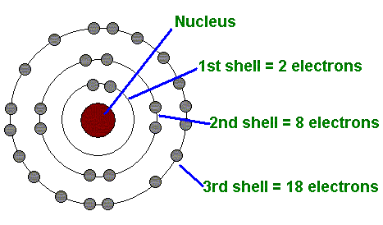

|  |
| --- |
| **3.7 Class Notes** |

**Principal Energy Levels**

#### Each principal energy level has a certain number of electrons that it can hold.

* When we label energy levels, the energy level _____________________ to the nucleus is considered to be _________________.
* Electrons want to be as _______________________ to the nucleus as possible, so fill the 1st energy level before moving to the 2nd.
* To calculate the number of electrons that can be in each we use the equation:

**2n2**, where n is the energy level.

|  |  |
| --- | --- |
| ENERGY LEVEL | TOTAL # OF ELECTRONS IT CAN HOLD |
| 1 |  |
| 2 |  |
| 3 |  |
| 4 |  |

**ELECTRON CONFIGURATION OF AN ATOM**

|  |  |
| --- | --- |
| **Electron Configuration** |  |

Example: **Carbon**  Atomic #: ______________

Electron Configuration: _________________________

Total # of energy levels: ________________________

# of Electrons in 1st level: ________________________

# of Electrons in 2nd level: ______________________

# of electrons in total: ___________________

|  |
| --- |
| **3.7 Class Notes** |

**Answer the following questions**

What is the total number of electrons needed to completely fill all the orbitals in an atom’s second principle energy level?

(1) 16 (2) 2 (3) 8 (4) 4

What is the maximum number of electrons that can occupy the fourth principal energy level of an atom?

(1) 6 (2) 8 (3) 18 (4) 32

Write the electron configuration for an atom that has 33 electrons.

Write the electron configuration for an atom that has 45 electrons.

**Identify the element based on the Bohr Model**

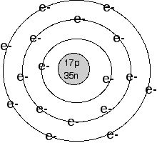 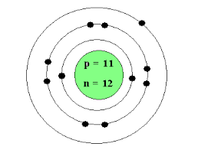

|  |
| --- |
| **3.7 Class Notes** |

**Ground State Electron Configuration versus Excited State Electron Configuration**

<http://learning.covcollege.ac.uk/content/Jorum/MET_Intro-to-photosynthesis_LM-1.2/page52.htm>

|  |  |  |
| --- | --- | --- |
|  | **Description of what is happening** | **What will happen to the electron?** |
|  |  |  |
|  |  |  |

**Do you see a pattern?**

|  |  |  |
| --- | --- | --- |
| **Element** | **Ground State** | **Excited State(s)** |
| **Carbon** | 2-4 | 2-3-1 or 1-5 |
| **Oxygen** | 2-6 | 2-5-1 or 1-7 |
| **Aluminum** | 2-8-3 | 2-7-4 or 2-8-2-1 |

1. Does the total number of electrons in an element change when the atom is in the ground state or the excited state?
2. How would you describe the difference between the ground state electron configuration and the excited state configuration?
3. Write one possible excited state configuration for F (fluorine).

|  |
| --- |
| **3.7 Class Notes** |

**Ground State vs. Excited State**

|  |  |
| --- | --- |
| **Ground State** |  |
| **Excited State** |  |

* When an atom enters an excited state, the ____________of electrons STAYS THE SAME but the _____________________ of the electrons CHANGES.
* In order for an electron to enter an excited state it must ___________________ energy

RESULT: Electron moves to a ____________________ energy level.

* Electrons can return to the ground state by ___________________ energy

RESULT: Electron moves to a ______________________ energy level.

|  |  |
| --- | --- |
| **Sample Question** | **Explanation of Answer** |
| Compared to a sodium atom in the ground state, a sodium atom in the excited state must have  A.) a greater number of electrons  B.) a smaller number of electrons  C.) an electron with greater energy  D.) an electron with less energy | KEY WORDS AND SYMBOLS:  EXPLANATION: |
| Which electron transition represents a gain of energy?  A.) from 2nd to 3rd shell  B.) from 2nd to 1st shell  C.) from 3rd to 2nd shell  D.) from 3rd to 1st shell | KEY WORDS AND SYMBOLS:  EXPLANATION: |

|  |
| --- |
| **3.7 Class Notes (Sample Questions)** |

|  |  |
| --- | --- |
| **Sample Question** | **Explanation of Answer** |
| Which electron configuration represents the electrons of an atom in an excited state?  (1) 2-4  (2) 2-6  (3) 2-7-2  (4) 2-8-2 | KEY WORDS AND SYMBOLS:  EXPLANATION:  ________________________________________________  ________________________________________________  ________________________________________________  ________________________________________________  ________________________________________________ |
| Which electron configuration represents an atom of chlorine in an excited state?  (1) 2-8-7  (2) 2-8-8  (3) 2-8-6-1  (4) 2-8-7-1 | KEY WORDS AND SYMBOLS:  EXPLANATION:  ________________________________________________  ________________________________________________  ________________________________________________  ________________________________________________  ________________________________________________ |
| In comparison to an atom of F-19 in the ground state, an atom of C-12 in the ground state has  (1) three fewer neutrons  (2) three fewer electrons  (3) three more neutrons  (4) three more electrons | KEY WORDS AND SYMBOLS:  EXPLANATION:  ________________________________________________  ________________________________________________  ________________________________________________  ________________________________________________  ________________________________________________ |

|  |
| --- |
| **3.7 Class Notes** |

**Write Excited State Electron Configuration**

**EXAMPLE #1: Write the electron configuration of sulfur in the excited state.**

* **Step 1:** Write the electron configuration of element in the ground state (see reference table)
* **Step 2:** Subtract one electron from an energy level and add it to the every level that follows it if it is not filled already.
* **NOTE:** If last level is filled, then create a new level with that electron.

**EXAMPLE #2: Write the electron configuration of neon in the excited state.**

|  |
| --- |
| **3.7 Class Work** |

**Answer the following questions**

What is the electron configuration of a sulfur atom in the ground state?

(1) 2-4 (2) 2-6 (3) 2-8-4 (4) 2-8-6

Which electron transition represents a gain of energy?

(1) from 2nd to 3rd shell (2) from 2nd to 1st shell

(3) from 3rd to 2nd shell (4) from 3rd to 1st shell

Which is an electron configuration for an atom of argon in the excited state?

(1) 2-8-7 (2) 2-8-8 (3) 2-8-6-1 (4) 2-8-7-1

Which electron configuration represents the electrons of an atom of oxygen in the ground state?

(1) 2-4 (2) 2-6 (3) 2-7-2 (4) 2-8-2

When compared with the energy of an electron in the first shell of a carbon atom, the energy of an electron in the second shell of a carbon atom is

(1) less (2) greater (3) the same

Which electron configuration represents the electrons of an atom in an excited state?

(1) 2–8–1 (2) 2–8–6 (3) 2–8–17–6 (4) 2–8–18–5

As an electron in an atom moves from the ground state to the excited state, the electron

1. gains energy as it moves to a higher energy level

(2) gains energy as it moves to a lower energy level

(3) loses energy as it moves to a higher energy level

(4) loses energy as it moves to a lower energy level

|  |
| --- |
| **3.7 Class Work** |

* Base your answer on the electron configuration table shown below.

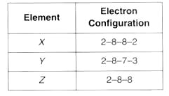

1. Which electron configuration represents the excited state of a calcium atom?
2. What is the element Z?

* Write an appropriate number of electrons in each shell to represent an Mg-26 atom in an excited state. Your answer may include additional shells.
* Write an appropriate number of electrons in each shell to represent an N-14 atom in an excited state. Your answer may include additional shells.
* Write an appropriate number of electrons in each shell to represent an Al-27 atom in an excited state. Your answer may include additional shells.

|  |
| --- |
| **Aim:**  **3.8** |
| **Objective:** |
| **Real world connection:** |
| **Vocabulary:** Lewis Dot structure, valence electrons, electron configuration |

**Valence Electrons**

**Electron configuration:** Shows the number of electrons in each energy shell. Also known as the **ground state** electron configuration.



**Ex.** How many electrons are in the first shell? ____

How many electrons in the 2nd shell? ______

How many electrons in the 3rd shell? _____

Valence electrons: __________

**Valence Electrons:** Number of electrons in the outermost shell.

**Try it on your own!**

Directions: Find the electron configuration for the following elements. Circle the valence electrons.

1. **Magnesium: ______________ 3. Xenon: ________________**
2. **Potassium: _______________ 4. Calcium: ______________**

|  |
| --- |
| **3.8 Class Notes** |

**Lewis Dot Structure**

**Drawing the Lewis dot diagram**

|  |  |
| --- | --- |
| **Lewis Dot Structures** |  |

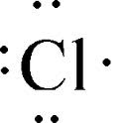

What is the electron configuration for Cl? _________________

How many valence electrons does it have? _________________

**Each dot represents a valence electron.**

**Steps:**

1. Write symbol of element
2. Find out number of valence electrons
3. Draw a dot representing each valence electron. (NOTE: Draw a dot on each side of the valence electron first before you start to pair up.)

**NOTES:**

A. Cannot have no more than 2 on any side of symbol

B. No more than 8 dots in total

**Examples:**

1) Be

2) F

|  |
| --- |
| **3.8 Class Work** |

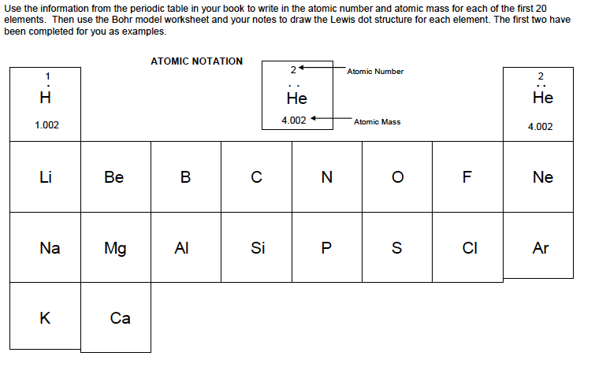

The valence electrons of a germanium atom in the ground state are located in the

A) first shell B) second shell

C) third shell D) fourth shell

Magnesium and calcium have similar chemical properties because a magnesium atom and a calcium atom have the same

A) atomic number

B) mass number

C) total number of electron shells

D) total number of valence electrons

Which set of symbols represents atoms with valence electrons in the same electron shell?

1. Ba, Br, Bi
2. Sr, Sn, I
3. O, S, Te
4. Mn, Hg, Cu

|  |
| --- |
| **3.8 Class Work** |

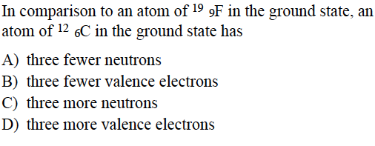**Answer the following questions:**

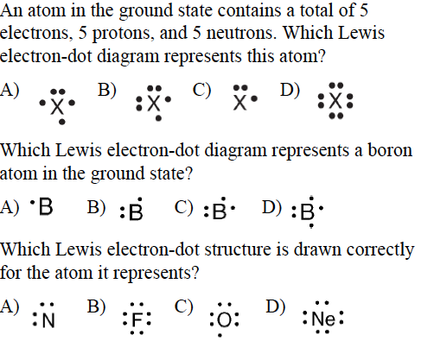

|  |
| --- |
| **Aim:**  **3.9** |
| **Objective:** |
| **Real world connection:** |
| **Vocabulary:** Isotope, hyphen notation, nuclear notation |

**How do neon lights work?**

**Adapted from** [**http://www.herebeanswers.com/2011/07/how-do-neon-and-fluorescent-lights-work.html**](http://www.herebeanswers.com/2011/07/how-do-neon-and-fluorescent-lights-work.html)

|  |
| --- |
|  |
|  |

[](http://1.bp.blogspot.com/-jhh_EiFeiNo/TiBd817J2dI/AAAAAAAAAKE/W6GstrCgnP8/s1600/neonlight.jpg)Cool and colorful, eerily radiant, a neon tube emits a light of almost seductive elegance. But mesmerizing as their shimmer may be, neon system owe their glow to nothing more glamorous than a bit of gas and a jolt of electricity. Sealed within the glass tubing of, say, an illuminated signboard is a mixture of gases, one of which will always be neon. Left to itself, neon remains still and colorless. It is only when a current of electricity is passed through the gas that it reveals its garish talents.   
  
When such an electrical change is applied, it stimulates electrons circling a neon atom’s nucleus. The suddenly excited electrons move farther away from the nucleus. This condition lasts only an instant. Almost immediately, the electrons return to their unexcited state, emitting a burst of energy that is visible, as a brilliant orange-red application of a coating of phosphor powder to the inside of the tube will yield commensurate changes in color.

1. Which subatomic particle plays a role in neon lights?

1. Describe what happens to this subatomic particle in order to produce neon lights?

____________________________________________________________________________________________________________________________________________________________________________________________________________________________________________________________________________________________________________________________________________________________________________________________________________________________________________________________________________________________________________________________________________________________________________________________________________________________________________

|  |
| --- |
| **3.9 Class Notes** |

**Atomic Emission Spectra**

* When atoms __________________ energy, their electrons move to ____________________ higher energy levels.
* When electrons return back to ________________ energy levels, electrons __________________ energy by ______________________________________.
* Energy absorbed by electron moving up = energy lost when moving back down to original level
* The amount of energy released when returning from excited state to ground state is __________________ for each element
* RESULT: each element has its own atomic emission spectrum

|  |  |
| --- | --- |
| **Atomic Emission/Bright Line Spectra** |  |

**Why do you think every element produces their unique set of spectral lines?**

**How are the bright line spectra like a fingerprint?**

|  |  |
| --- | --- |
| **THINK INK** | **PAIR SHARE** |
|  |  |

|  |
| --- |
| **3.9 Class Work** |

|  |  |
| --- | --- |
| **Sample Question** | **Explanation of Answer** |
| The characteristic bright-line spectrum of an element occurs when electrons  A.) move from lower to higher energy levels  B.) move from higher to lower energy levels  C.) are lost by a neutral atom  D.) are gained by a neutral atom | KEY WORDS AND SYMBOLS:  EXPLANATION: |
| Which of the following quantum leaps would be associated with the greatest energy of emitted light?  A.) n = 5 to n = 1  B.) n = 4 to n = 5  C.) n = 2 to n = 5  D.) n = 5 to n = 4 | KEY WORDS AND SYMBOLS:  EXPLANATION: |
| During a flame test, ions of a specific metal are heated in the flame of a gas burner. A characteristic color of light is emitted by these ions in the flame when the electrons   1. gain energy as they return to lower energy levels 2. gain energy as they move to higher energy levels 3. emit energy as they return to lower energy levels 4. emit energy as they move to higher energy levels | KEY WORDS AND SYMBOLS:  EXPLANATION: |
| When the electrons of an excited atom return to a lower energy state, the energy emitted can result in the production of   1. alpha particles 2. isotopes 3. protons 4. spectra | KEY WORDS AND SYMBOLS:  EXPLANATION: |

|  |
| --- |
| **3.9 Class Notes** |

**Appearance of Atomic Emission Spectra**

*Directions: Match up lines of elements we know to the unknown sample.*

**Which two elements are present in the unknown spectra below?**

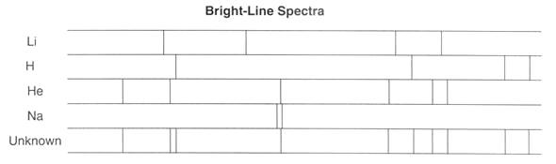

*A.) Li & H*

*B.) Li & Na*

*C.) H & He*

*D.) Li & He*

Explain how a bright-line spectrum is produced, in terms of excited state and ground state.

**Practice Regents Question**

**Identify all the elements in the mixture: _______________________________________________________________**

|  |
| --- |
| **3.9 Class Work** |

Many advertising signs depend on the production of light emissions from gas-filled glass tubes that are subjected to a high-voltage source. When light emissions are passed through a spectroscope, bright-line spectra are produced.

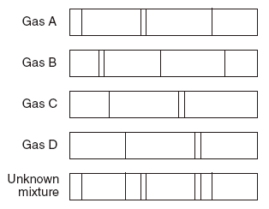

Identify the *two* gases in the unknown mixture.

1. *A* and *B*
2. *A* and *D*
3. *B* and *C*
4. *C* and *D*

Given the bright-line spectra of three elements and the spectrum of a mixture formed from at least two of these elements:

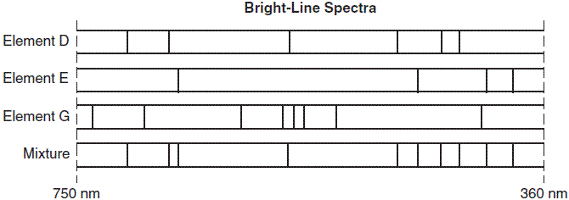

Which elements are present in this mixture?

1. *E* and *D*, only
2. *E* and *G*, only
3. *D* and *G*, only
4. *D*, *E*, and *G*

|  |
| --- |
| **3.9 Class Work** |

A glass tube is filled with hydrogen gas at low pressure. An electric current is passed through the gas, causing it to emit light. This light is passed through a prism to separate the light into the bright, colored lines of hydrogen’s visible spectrum. Each colored line corresponds to a particular wavelength of light. One of hydrogen’s spectral lines is red light with a wavelength of 656 nanometers. Tubes filled with other gases produce different bright-line spectra that are characteristic of each kind of gas. These spectra have been observed and recorded.

1. Explain, in terms of electron energy states and energy changes, how hydrogen’s brightline spectrum is produced. [1]
2. Explain how the elements present on the surface of a star can be identified using brightline spectra. [1]
3. A student measured the wavelength of hydrogen’s visible red spectral line to be 647 nanometers. In the space in your answer booklet, show a correct numerical setup for calculating the student’s percent error. [1]

Below you will find the known spectra for five common elements followed by the spectrum recorded by a telescope for a distant star. Examine the spectra and answer the questions that follow.

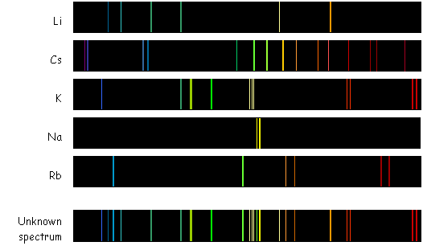Which element is *not* in the star that produced the “unknown spectrum”? How can you tell?

|  |
| --- |
| **3.9 Class Work** |

**DIRECTIONS:** Read the following passage about fireworks and answer the following questions.



Behind the scenes of the dazzling light shows that spectators ooh and ahh at on the Fourth of July, are carefully crafted fireworks. Whether red, white and blue fountains or purple sparklers, each firework is packed with just the right mix of chemicals to create these [colorful lights](http://www.lifeslittlemysteries.com/what-causes-bioluminescence--0863/).

Inside each handmade firework are small packets filled with special chemicals, mainly metal salts and metal oxides, which react to produce an array of colors. When heated, the atoms of each element in the mix absorb energy, causing its [electrons to rearrange](http://www.lifeslittlemysteries.com/where-do-electrons-get-energy-to-spin-around-an-atoms-nucleus-0587/) from their lowest energy state to a higher "excited" state. As the electrons plummet back down to their lower energy state, the excess [energy gets emitted as light](http://www.lifeslittlemysteries.com/what-causes-the-aurora-0886/).

Each element releases a different amount of energy, and this energy is what determines the [color](http://www.lifeslittlemysteries.com/how-do-fireworks-get-their-colors-0904/) or wavelength of the light that is emitted.  
  
For instance, when sodium nitrate is heated, electrons in the sodium atoms absorb the energy and get excited. When the electrons come down from the high, they [release their energy](http://www.lifeslittlemysteries.com/how-does-air-conditioning-cool-the-air-0834/), about 200 kilojoules per molecule, or the energy of yellow light, according to the website of the University of Wisconsin-Madison chemistry professor Bassam Z. Shakhashiri.  
  
The [recipe](http://www.lifeslittlemysteries.com/how-do-fireworks-get-their-colors-0904/) that creates blue, for example, includes varying amounts of copper chloride compounds, while red comes from strontium and lithium salts.  
  
Just like paints, secondary colors are made by mixing the ingredients of their primary-color relatives. A mixture of copper (blue) and strontium (red) makes purple.

***READING COMPREHENSION QUESTIONS:***

1. When do electrons release energy?

________________________________________________________________________________________________________________________________________________________________________

1. Where does the energy that moves ground state electrons into the excited state in fireworks come from?

________________________________________________________________________________________________________________________________________________________________________

1. What two things determine the color of the light that each firework produces?

________________________________________________________________________________________________________________________________________________________________________

1. How does this article relate to the concept we learned today in class?

_______________________________________________________________________________________________________________________________________________________________________________________