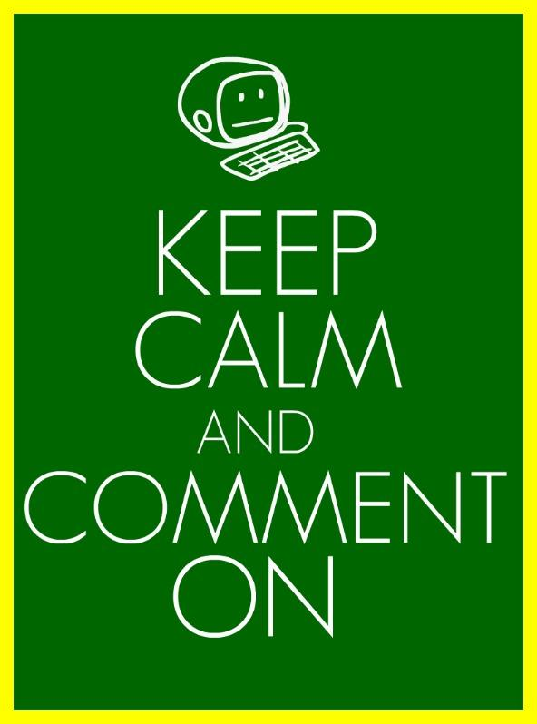
Peer Feedback Sheet
Evaluator (Your Name): _______________________________________________
Presenters: ____________________________________________________________

FEEDBACK PROMPTS

Praise #1: “Today you did well on…”

Evidence:

Praise #2: “Today you did well on…”

Evidence:

Constructive Criticism #1: “One thing you could work on improving is…”

Evidence:

Constructive Criticism #2: “One thing you could work on improving is…”

Evidence:

Wondering: “One thing I found interesting is…” or “One thing I was wondering was…” or “One question I had”

Suggestion: “Next time you could try…”

Rate the Presentation Based on Rubric:
Course SKILL 2: SWBAT create a presentation that visually and creatively demonstrates knowledge of a topic.
Objectives within this Learning Goal:
- SWBAT compile and deliver most important information in a concise way.
- SWBAT develop questions that assess peer’s new knowledge from presentation.
- SWBAT engage presenters by selecting appropriate visuals, videos, and activity
1 | 2 | 3 | 4
Cannot understand presentation--no sequence of information. Images are distracting and layout is confusing. Presentation is completely hard to read and has many mistakes. | Difficult to follow presentation--student jumps around. Images are clipart. Images are too small/large in size, or of poor quality (fuzzy). Layout shows some structure. Presentation is somewhat hard to read and has some mistakes | Information in logical sequence. Most slides contain one powerful, high quality image, which helps audience understand the content. Layout uses most space appropriately. Presentation is fairly easy to read and has only a few mistakes. | Information presented in logical, interesting sequence. All slides contain one powerful, high-quality image per slide, which helps audience understand the content. Layout of images is pleasing to eye. Presentation very easy to read and no mistakes.
Assessment: Lesson Plan Project |  | Reassessment opportunities:  1. Lesson Plan Corrections
Why did you choose that number?

Course SKILL 3 : SWBAT professionally present academic work in front of an audience.
Objectives within this Learning Goal:
- SWBAT determine what is the proper resource site.
- SWBAT collect most important information from research on their topic.
- SWBAT summarize in their own words the research collected.
- SWBAT demonstrate the explicit steps of their thinking, showing the logic that leads from evidence to claim.
1 | 2 | 3 | 4
Audience cannot understand presentation because there is no sequence of information. Reads with no eye contact and incorrectly pronounces terms. Speaks too quietly. Student is unable to answer questions | Audience has difficulty following presentation because student jumps around. Occasionally uses eye contact, mostly reading presentation, and incorrectly pronounces terms. Audience members have difficulty hearing. Student has difficulty answering many questions | Student presents information in logical sequence which audience can follow. Maintains eye contact most of the time and pronounces most words correctly. Most audience members can hear presentation. Student answers most questions | Student presents information in logical, interesting sequence which audience can follow. Maintains eye contact and pronounces all terms precisely. All audience members can hear. Student answers all questions clearly and completely.
Assessment: Lesson Plan Project |  | Reassessment opportunities:  Lesson Plan Corrections
Why did you choose that number?

