QUESTION 1

Identify the major SI unit used for the following quantities:

- Mass: SI unit = ______
- Volume: SI unit = ______
- Temperature: SI unit = ______
- Length: SI unit = _______

QUESTION 2

One kilosecond is the same as
a. 0.001 s
b. 0.01 s
c. 100 s
d. 1,000 s

QUESTION 3

Translate the following symbols into units:

- mm: __________________
- K: _____________________
- ks: ____________________
- pL: ____________________

QUESTION 4

Write the correct symbol for the following units:
- nanosecond = __________
- microliter = ____________
- kilogram = _____________
- centimeter = __________

QUESTION 5

If the mass of a block is 1035 g and the volume is 310 cm³, what is the density of that object?

QUESTION 6

In an experiment, a student found the mass of an object to be 23.61g and the volume of an object to be 3 cm³. What element did the student take measurements of?

QUESTION 7

Identify the major instruments used to measure the following quantities:

- Mass: Instruments = ______
- Volume: Instruments = ______
- Temperature: Instruments = ______
- Length: Instruments = _______

QUESTION 8

A student estimated a mass to be 250g, but upon measuring it carefully, found the actual mass to be 240g. What is the percent error?

QUESTION 9

Which element has the greatest density at STP?
- Nitrogen
- Nickel
- Neon
- Niobium

QUESTION 10

Find the volume of an object that has a density of 1.54 g/cm³ and a mass of 0.4g.

QUESTION 11
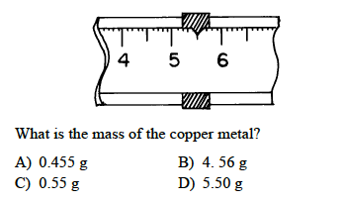

QUESTION 12

A student measures the mass and volume of a piece of lead. The measurements are 70.8 grams and 6.5 cubic centimeters. The student calculates the density of the lead. What is the percent error of the student’s calculated density of lead?

QUESTION 13

Determine whether the following is accurate and/or precise. Explain why!

QUESTION 14

Find the mass of an object that has a density of 9.70 g/mL and a volume of 3.2mL.

QUESTION 15

An experimental measurement was taken of 10.4mL and the actual measurement was 9.7mL. What is the percent error?

QUESTION 16

- Base your answer on A student used a balance and a graduated cylinder to collect the following data.

Sample mass: 7.83g
Volume of water: 50.0mL
Volume of water and sample: 52.5mL

a Calculate the density of the element. Show your work.

b If the accepted value is 3.5 grams per milliliter, calculate the percent error.

